Robert D. Robichaux
October 20, 1934 – August 23, 2018

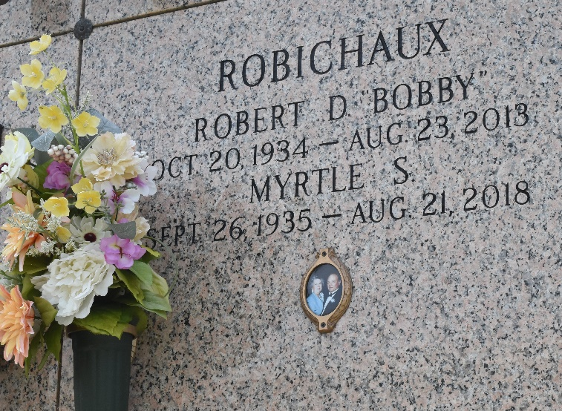

ROBERT D. ROBICHAUX on Friday, August 23, 2013 at his home in LaPlace, LA. Son of the late Ethelyn and Joseph Leo Robichaux, Sr. Loving Husband of Myrtle Simoneaux Robichaux. Father of Jodi Bleakley (Barry), Scott Robichaux (Mona), Drew Robichaux and the late Keith Robichaux. Brother of J. L. Robichaux, Jr., Lynn Robichaux, Peggy Englade and the late Veronica Robichaux. Grandfather of Jessica Galatas, Ashley Russell (Jeremy), Christina Briscoe (Michael), Cody Robichaux and Bethani Robichaux. Also survived by a host of nieces, nephews, cousins, other relatives and friends.
Age 79 years. A native of Norco, LA and a resident of LaPlace, LA. He worked as an operator at Dupont for 25 years and also as owner of Robichaux's A/C and Electrical. His favorite past times included caring for an abundance of rose bushes, hunting, fishing and shrimping.
Relatives and friends of the family are invited to attend the Funeral Mass at St. Joan of Arc Catholic Church, 529 West 5th Street, LaPlace, LA on Monday, August 26, 2013 at 12 Noon. Interment St. John Memorial Garden Cemetery, LaPlace, LA. Visitation at the above-named church from 9:30 AM until Mass time. SERVICED BY ROBOTTOM
The Times-Picayune, New Orleans, Louisiana
Aug. 24 to Aug. 25, 2013

