Hannah Lee (Wilson) Robinson
February 29, 1940 – April 5, 2021
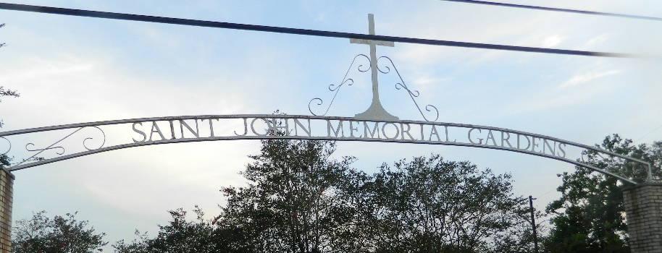

Hannah was born on February 29, 1940 to the union of the late Henry and Rozelia Wilson, in LaPlace, LA. She departed this earthly life on Monday, April 5, 2021 at the age of 81.
Her desire to help others led her to pursue a career in nursing. She attended Jefferson Vocational Technical School, where she graduated as an LPN. Hannah was a great cook, and she loved cooking for her family, especially for holiday gatherings. She also loved to crochet and sew. Her first love was serving Jesus. She was baptized at Our Lady of Grace Catholic Church, and she continued to praise and worship the Lord with nondenominational affiliation.
She met the love of her life, the late Ivory L. Robinson, son of the late Herbert and Bertha Robinson of LaPlace, LA. After a whirlwind courtship that lasted 3 months, they were married on July 25, 1959. They were truly a match made in Heaven, and they remained married until Ivory Sr.’s demise on August 8, 2007. Hannah and Ivory raised three adoring children: April, Ivory Jr. and Suzanne.
Hannah was preceded in death by her daughter April R. Victor; sister, Laura Ann Wilson Poe; sons-in-law, Paul Eugene and Kenneth Victor; and her daughter-in-law, Julia (Ivory, Jr.).
She leaves to cherish her memories her sisters, Diane W. Hood, Alice and Gladys Wilson; brothers, Henry, Jr. and Ernest Wilson; grandchildren, Kaream, Courtney and Chloe Robinson, Candace, Andrea, Brandy (Jonathan), Ivory III (Nicole), Christian and Jared; great-grandchildren, Joel Jr, Caleigh, Zoe, Jonathan Jr., Gabrielle, Ivy and Niko, and a host of other family members and friends.
A celebration of life for Hanna Lee Robinson will be held on Saturday, April 10, 2021 at Treasures of Life Funeral Services, 315 E. Airline Hwy, Gramercy, LA. Visitation from 10am-11pm. Private family service to follow. Interment to follow at St. John Memorial Gardens in LaPlace, LA.

Treasures of Life Funeral Services, Gramercy, Louisiana

