Ivory Robinson Sr.
April 8, 1933 – August 8, 2007

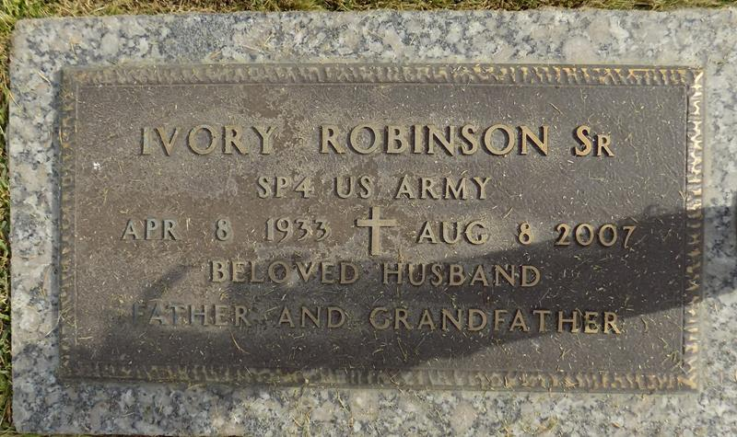

Ivory Robinson, age 74, a loving husband, father, and grandfather went home on Wednesday, August 8, 2007 of cardiovascular failure at Ochsher of Kenner.
He was the son of the late Herbert Robinson and Bertha Tassin-Robinson. Ivory graduated from Gaudet High School and Texas College and retired from the U.S.P.S. of Gretna, LA in 1995. He was a native New Orleanian and served in U.S. Army.
Ivory is survived by his wife of 48 years, Hannah Wilson Robinson. He was preceded in death by April Robinson-Victor and survived by Ivory L. Robinson, and Suzanne Eugene. Also preceded in death by Norman Robinson (BertEthel), Herbert Robinson Jr., and Inez Johnson (Allen). He was also survived by 9 grandchildren, 1 great-grandchild, a niece, Karen Coney (James), Calvin Gasper, Norman Robinson Jr. (Doris), five sisters-in-law, 2 brothers-in- law and a host of aunts, uncles, great nieces, great nephews, and cousins.
Funeral Services were privately held by Hobson-Brown.

Times-Picayune, The (New Orleans, LA)
Wednesday, August 15, 2007

