Pherrell Rodgers

February 15, 1957 – February 11, 2011

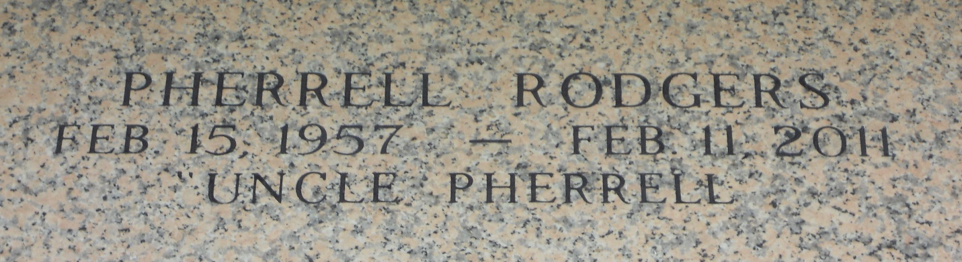

Photo by Team T-Lo

Pherrell Rodgers, age 53, departed this life on Friday, February 11, 2011 in Laplace, La. Brother of Avis Johnson, Arnold, Wilis, and Cleveland Anderson. A native and resident of Laplace, La.

Funeral Service on Thursday, February 17, 2011 at 11:00a.m. at the Rising Star B.C., 620 Cardinal St., Laplace, La. Rev. Donald August Pastor Officiating. Interment in St. John Memorial Garden Laplace, La. Viewing at the church on Thursday at 10:00a.m. until service time. Service Entrusted to Hobson Brown Funeral Home 134 Daisy St., Garyville, La. 70051 985-535-2516

The Times-Picayune, New Orleans, Louisiana

Feb. 16, 2011