Jonathan Anthony Rodrigue
June 9, 1986 – May 22, 2022

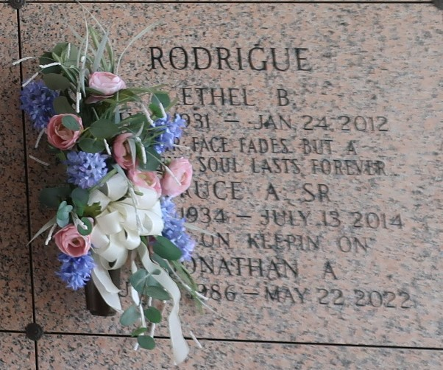

Jonathan Anthony Rodrigue, age 35, his earthly journey ended on Sunday, May 22, 2022 with his furry friend, Benny, by his side. Born June 9, 1986 in Kenner, LA. He was a native of Jefferson Parish and St. Charles Parish before moving to Snowmass, CO. He worked for Aspen Skiing Company Housing where his co-workers described him as someone who showed kindness and was always willing to lend a helping hand with a smile.
He leaves behind his beloved dog, Benny, that he took on hikes and fishing trips. Snowboarding was another favorite activity that Jonathan enjoyed.
Survived by his mother Tammy Mineo-Freed (Ted) and his father Bruce A Rodrigue Jr. Grandparents Ronald & Marion (Ann) Mineo Sr. His siblings Ryan and Ashley Zimmermann. Aunt and Uncles; Ronald (Andy) Mineo Jr, Pam M Albanese (Michael), Shelia R Gauthier (Pat), Angel R. Cheramie (Bryan), Melanie R Haydel (Richard), Linda R Boudreaux (Mike) and many cousins. He is preceded in death by his grandparents Bruce and Ethel Rodrigue Sr.
Services will be held on Friday, June 10, 2022 at Saint Matthew the Apostle Catholic Church located at 10021 Jefferson Hwy. River Ridge, LA 70123. Visitation will begin at 10:30am followed by a Mass at 12pm. Private interment to follow at St. John Memorial Gardens Cemetery in LaPlace, LA.

The Times-Picayune, New Orleans, Louisiana
Jun. 6 to Jun. 10, 2022

