Kathleen Ann (Crabtree) Rodrigue
April 3, 1943 – March 18, 2017
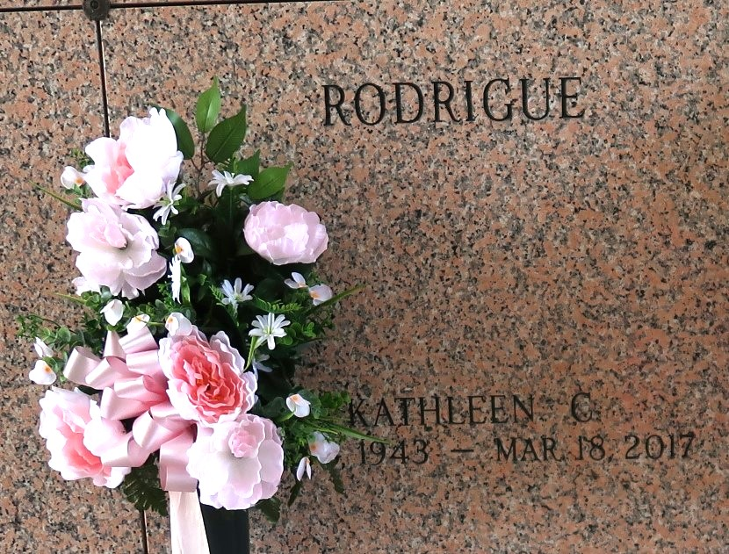

A native and life-long resident of LaPlace, LA, KATHLEEN CRABTREE RODRIGUE passed away on Saturday, March 18, 2017 at 4:24 p.m. at her residence at the age of 73.
She was the beloved wife of Robert “Rod” Rodrigue. Mother of Lisa Bordelon and Andy Rodrigue. Mother-in-law of Terry Bordelon and Jeannette Rodrigue. Grandmother of Austin Rodrigue, Katelyn Rodrigue, Mason Bordelon and Marc Bordelon. Daughter of the late Viage “Pete” and Marie Rome Crabtree. Sister of Gary Crabtree and Sister-in-law of Edie Crabtree. Aunt of Deena Trisler and Shanna Harrison.
Kathleen was a retired cafeteria manager of the St. Joan of Arc School in LaPlace, LA. She enjoyed her time at St. Joan of Arc and loved her fellow cafeteria workers and the entire St. Joan of Arc school and church family. She missed her SJA family but enjoyed her retirement and spent time reading and traveling with her husband and family.
The family would like to thank Davita & Egan Home Health for the excellent care they provided.
Relatives and friends are invited to attend the Funeral Mass at St. Joan of Arc Catholic Church, 529 W. 5th St., LaPlace on Wednesday, March 22, 2017 at 12:00 p.m. Visitation at the church from 10:00 a.m. to 12:00 p.m. Interment in St. John Memorial Gardens Cemetery. Arrangements by Millet-Guidry Funeral Home.
Millet-Guidry Funeral Home, LaPlace, Louisiana

