Louis H. Rodrigue, Sr.
June 26, 1953 – December 10, 2021

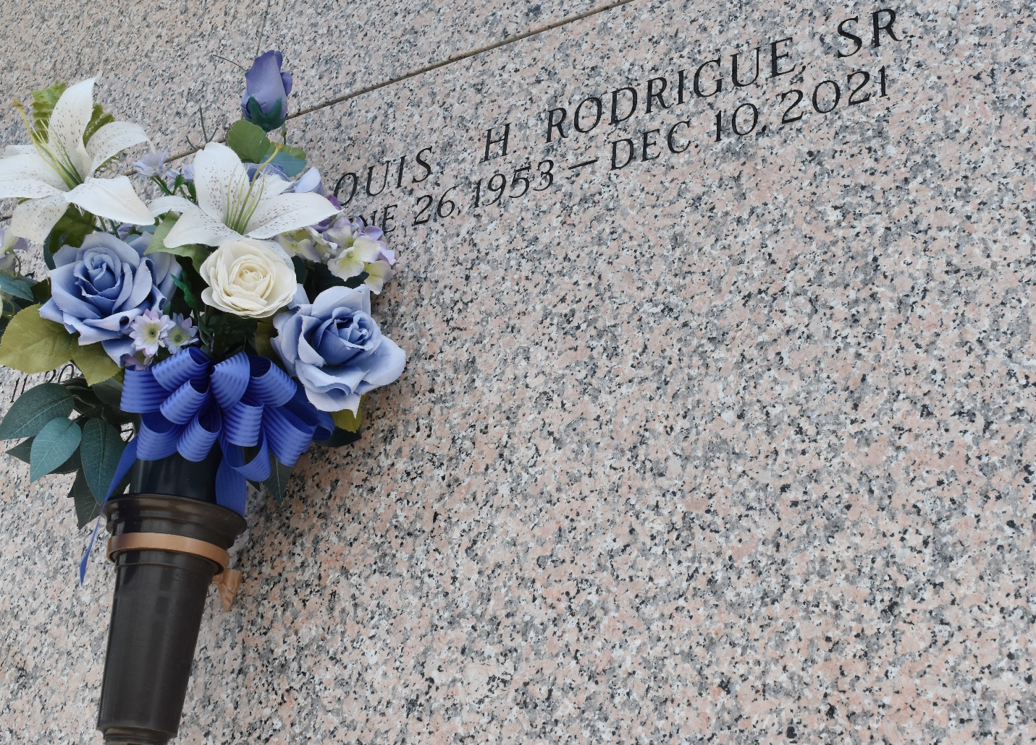

Louis H. Rodrigue, Sr. passed away on Friday, December 10, 2021 at the age of 68. He was a native and lifelong resident of LaPlace, Louisiana.
Beloved father of Louis H. Rodrigue, Jr. (Angela), Billy Rodrigue (Necole) and Chris Rodrigue (Jenny). Son of the late Pearl Bruno Rodrigue and Francis Rodrigue, Sr. Brother of Sue Burns, Francis Rodrigue, Jr., Terry Rodrigue, Sr., Scott Rodrigue, Kim Ralser and Penny Forbes. Also survived by many grandchildren and great grandchildren.
Relatives and friends are invited to attend the Visitation and Funeral Service at Millet-Guidry Funeral Home, 2806 W. Airline Hwy., LaPlace, LA on Friday, December 17, 2021. Visitation from 9:00 a.m. to 11:00 a.m. followed by a Funeral Service at 11:00 a.m. Interment in St. John Memorial Gardens Cemetery, LaPlace, LA.
Published on Legacy.com by Millet-Guidry Funeral Home
Dec. 14, 2021 to Jan. 4, 2022

