Tanya Gail Rodrigue
June 6, 1957 – March 4, 2006
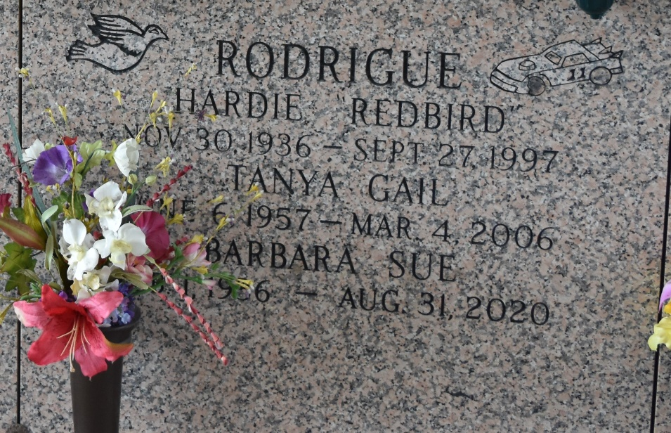

Tanya G. Rodrigue on Saturday, March 4, 2006 at 1:08 am. Beloved daughter of Barbara Gaspard Rodrigue and the late Hardie (Redbird) Rodrigue. Sister of Michel and Don Rodrigue, Lisa Rodriquez and Sandra Cosentino. Also survived by nieces and nephews and great nieces and nephews. Age 48 years, a native and resident of LaPlace.
Relatives and friends of the family are invited to attend services. Visitation at St. Joan of Arc Catholic Church, LaPlace, LA. on Monday, March 6, 2006 from 9am to 10am. Followed by Religious Services at the church at 10am. Burial in St. John Memorial Gardens Cemetery, LaPlace, LA. MILLET-GUIDRY FUNERAL HOME in charge of arrangements.
The Times-Picayune, New Orleans, Louisiana
Mar. 5, 2006

