April (McKinnon) Rodriguez
January 22, 1959 – December 9, 2012

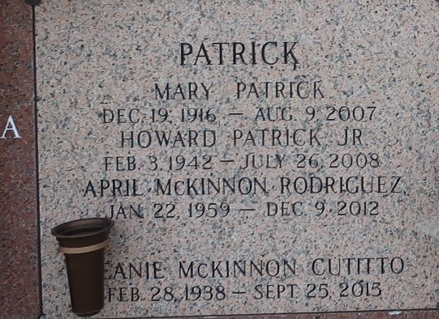

April McKinnon Rodriguez passed away on Sunday December 9, 2012.
Beloved wife of Demetrio Rodriguez. Mother of David Morris, Amie Morris, Robert Morris and Victoria Rodriguez. Also survived by 5 grandchildren. Daughter of Vernon McKinnon and Jean McKinnon. Sister of Kellie Simmons, Steve McKinnon and Clayton McKinnon. Age 53. A native of Arizona and a resident of LaPlace, LA.
Private services to be held at a later date. Arrangements by Millet-Guidry Funeral Home, LaPlace, LA
The Times-Picayune, New Orleans, Louisiana
Dec. 12 to Dec. 14, 2012

