Ida Helen (Gutierrez) Rodriguez
February 6, 1922 – June 5, 2005

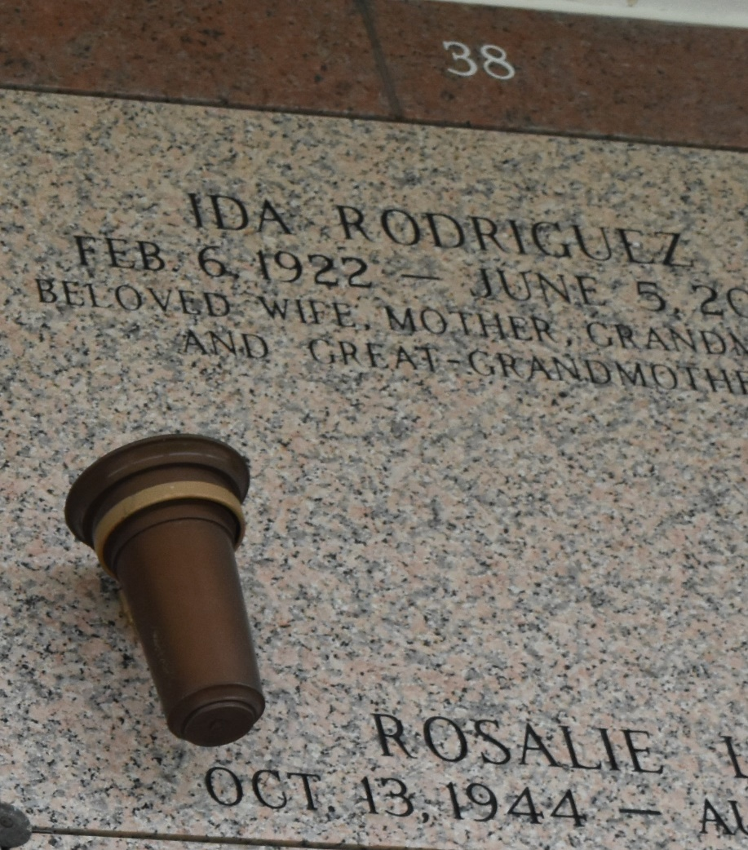

Ida Helen Rodriguez died on Sunday, June 5, 2005 at 11:40 AM. She was age 83 and a resident of Laplace, LA since 1977. Beloved wife of Harris A. Rodriguez. Beloved mother of Rosalie A. Lee, Maria P. LeBlanc and her husband Paul, and the late Charles W. Pedigo and his widow Suzanne. Grandmother of Daniel D. Lee and his wife Dora, Rachel M. Badie and her husband Tooraj and Jeffrey P. LeBlanc and his wife Melanie. Great grandmother of Devan Lee, Dylan Lee and Kian Badie. Sister of Ralph Gutierrez, Armand Gutierrez and the late Amato Gutierrez, Jr., George Gutierrez, and Gilbert Gutierrez. Daughter of the late Amato and Gaudalupe Gutierrez. Relatives and friends of family are invited to attend services. Visitation at Millet Guidry Funeral Home, 2806 West Airline Hwy, Laplace, LA on Wednesday, June 8, 2005 from 9:00AM -11:00AM. Followed by Religious Services in the funeral home chapel at 11:00AM. Burial in St. John Memorial Gardens, Laplace, LA.

The Times-Picayune, New Orleans, Louisiana
June 7, 2005

