Antoinette (Dottolo) Rollo
September 27, 1941 – February 6, 2021

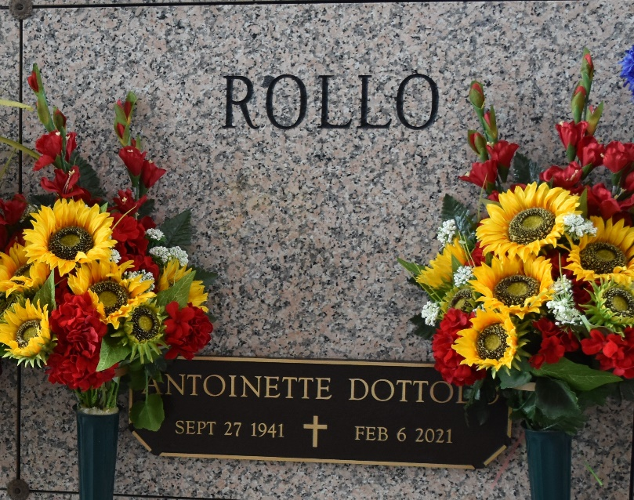

Antoinette Dottolo Rollo passed away on Saturday, February 6, 2021 at the age of 79. She was born and was a lifelong resident of LaPlace, LA.
Beloved wife of Vincent Joseph Rollo of 59 years. Loving mother of Michael Rollo (Rachelle) and Donna DiCarlo (Perry). Daughter of the late Helena Correnti Dottolo and Paul Dottolo. Sister of the late Felix Dottolo, Frank Dottolo, Tony Dottolo, Mary Accomando and Peter Dottolo. Also survived by 7 grandchildren and 5 great-grandchildren.
The family would like to express their heartfelt appreciation to the staff of Fresenius Kidney Care of LaPlace and Anvoi Hospice Care for their loving Care.
Relatives and friends are invited to attend the Visitation and Funeral Mass at St. Joan of Arc Catholic Church, 529 W. 5th Street, LaPlace on Tuesday, February 9, 2021. Visitation will be held at the church from 9:30 a.m. until 1:00 p.m. followed by a Funeral Mass at 1:00 p.m. Interment in St. John Memorial Gardens Cemetery. In lieu of flowers, please consider a donation in her memory to St. Jude Children’s Hospital.

Millet-Guidry Funeral Home, LaPlace, Louisiana

