James Kerry Rome
September 26, 1953 – April 18, 2018

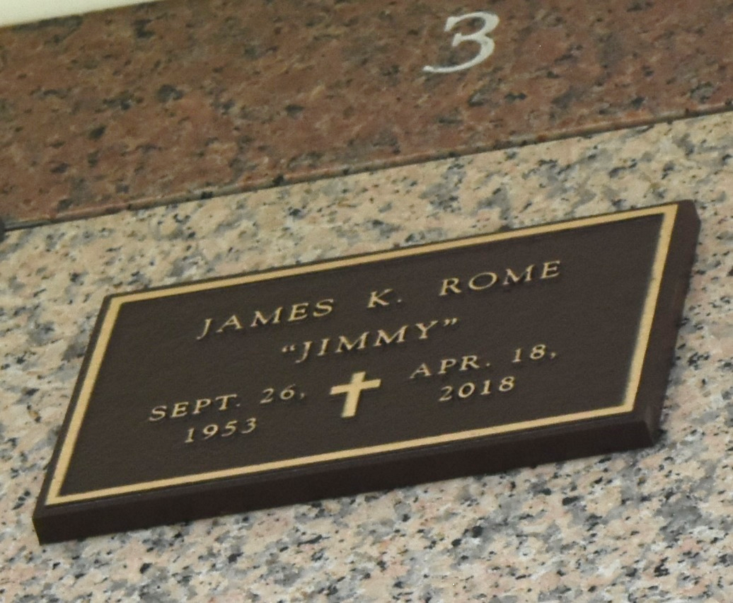

James Kerry Rome, age 64, passed away on Wednesday, April 18, 2018 at Ochsner West Bank Hospital in Gretna.
He is survived by his sisters, Diana Bordelon and Denise Tarlton.
A memorial visitation and service will be held on Saturday, April 21, 2018 at Rose Lynn Funeral Services, 1870 Cabanose Ave., Lutcher, LA.
Rose Lynn Funeral Home, Lutcher, Louisiana
**
James was born on September 26, 1953 and passed away on Wednesday, April 18, 2018. James was a resident of Lutcher, Louisiana at the time of passing.
Published by Rose Lynn Funeral Services on Apr. 21, 2018

