Bonnie Pauline (Dubois) Rongey
December 3, 1932 – September 26, 2020

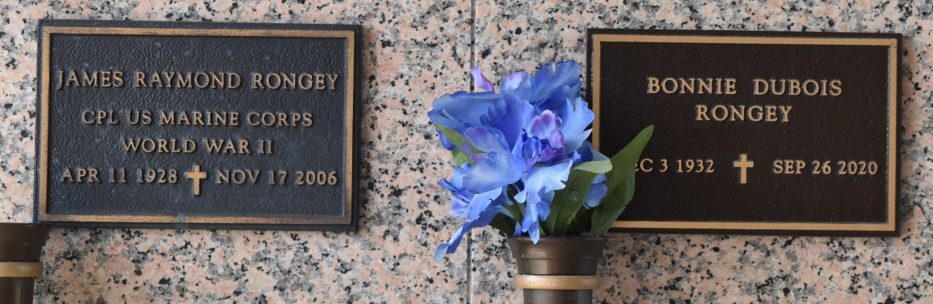

Bonnie Pauline Dubois Rongey passed into eternal life on September 26, 2020.
She was born on December 3, 1932 to Clarence and Vivian Miller Dubois in Lecompte, La. Bonnie was preceded in death by her beloved husband, James R. Rongey. She is survived by her children, Vicki Willard and husband, Wendell; James M. Rongey and wife, Yvonne; and Catherine Rongey. She is also survived by two grandchildren, Benjamin Rongey (Tiffany) and Marianne Rongey, and her brother, Jon D. Dubois.
Bonnie was a teacher in St. John Parish Schools for 20 years, travelled and camped extensively in the U.S and Canada, was an avid tennis player, and an award winning watercolor artist.
A private interment will be held at a later date in St. John Memorial Gardens in LaPlace.

L’Observateur, Laplace, Louisiana
Thursday, October 1, 2020

