James Raymond Rongey
April 11, 1928 – November 17, 2006

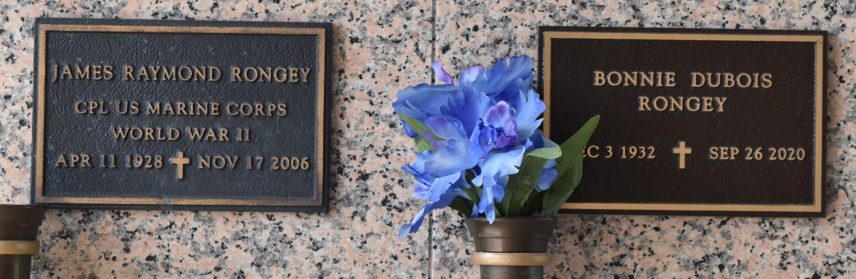

James R. Rongey on Friday, November 17, 2006 at 1:00 a.m.
Beloved husband of Bonnie Dubois Rongey. Father and father-in-law of Vicki and Wendell Willard of Atlanta, GA, James and Yvonne Rongey of LaPlace, LA and Catherine Rongey of Atlanta, GA. Grandfather of Benjamin and Marianne Rongey. Age 78 years. A native of Woodville, MS and a resident of LaPlace, LA for the past 43 years.
Relatives and friends of the family; also employees of Dupont, and members of the Masons are invited to attend services. Visitation at MILLET-GUIDRY FUNERAL HOME, 2806 W. Airline Hwy., LaPlace, LA on Tuesday, December 5, 2006 from 4:00 p.m. until 8:00 p.m. and on Wednesday from 9:00 a.m. until 10:00 a.m. Followed by Religious Services in the Funeral Home Chapel at 10:00 a.m. Burial in St. John Memorial Gardens, LaPlace, LA.
The Times-Picayune, New Orleans, Louisiana
Dec. 3 to Dec. 4, 2006

