Shirley Mae (Primo) Ross

December 19, 1937 – December 19, 2001

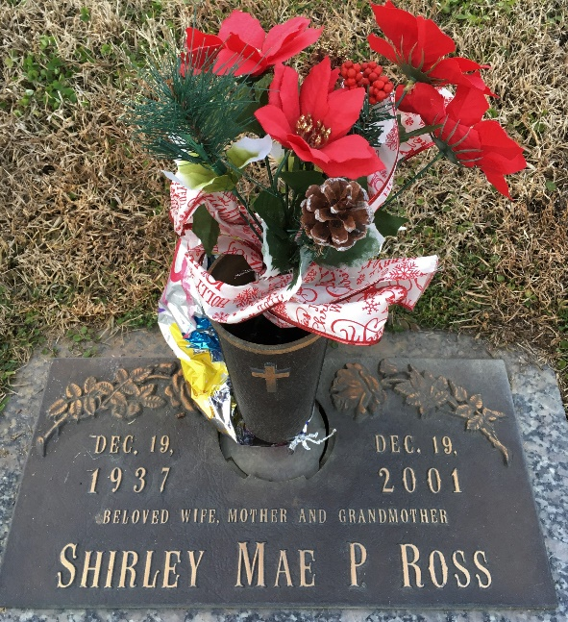

Photo by Team T-Lo

Shirley Mae Primo Ross, 64, a native of New Orleans and resident of LaPlace, died Dec. 19.

She was the wife of Norman Ross and mother of Donna Duhe, Carrie Hays and James Ross. She was the daughter of the late Earl Primo and Mildred Robinek and sister of Barbara Picone and the late Earl Primo Jr. She is also survived by eight grandchildren and three great-grandchildren.

Services were Dec. 22 in the chapel of H.C. Alexander Funeral Home, Lutcher, with interment at St. John Memorial Gardens, LaPlace.

L'Observateur, LaPlace, Louisiana

December 29, 2001