Diane Marie Runner

December 8, 1949 - May 20, 2018

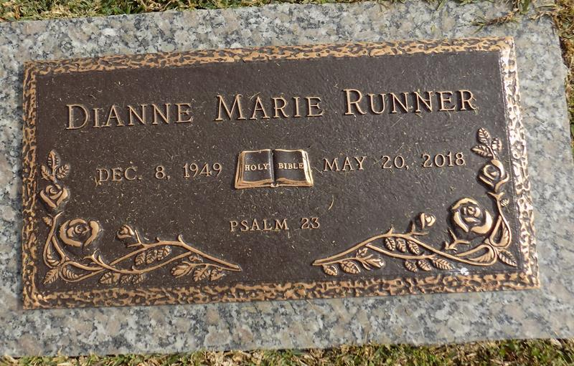

Dianne Marie Runner departed this life on Sunday, May 20, 2018.

Daughter of the late Florence Strigus. Mother of Aaron Cornell (Elmiko) Runner. Sister of Linda (Overton) Ross. Grandmother of Ariana Runner, Tiara Gomez; (3) Step Grandchildren Darremika, Darrell Jr., and Darren Tillery, Sr. Sister-in-law of Stephanie Batiste Brown. Dianne is survived by a host of nieces, nephews, other relatives and friends.

Celebration Service will be on Saturday, June 02, 2018 at New Zion Christian Center, 216 W. Main St., Gramercy, La, at 10:00 am. Visitation at 8:00 am. Rev. Emil Dean Mitchell, Sr. Pastor, officiating. Interment in St. John Memorial Laplace, La 70068. Employees of West Jefferson Hospital, Greg's Supermarket, Lafarge Holmium and Advance Care Providers are invited to attend. Professional Services entrusted to the caring staff Hobson Brown Funeral Home, 134 Daisy St., Garyville, La 70051, (985) 535-2516.

The New Orleans Advocate, Louisiana

May 31 to Jun. 2, 2018