Alger Joseph Sanders Jr.

August 21, 1947 – April 5, 2007

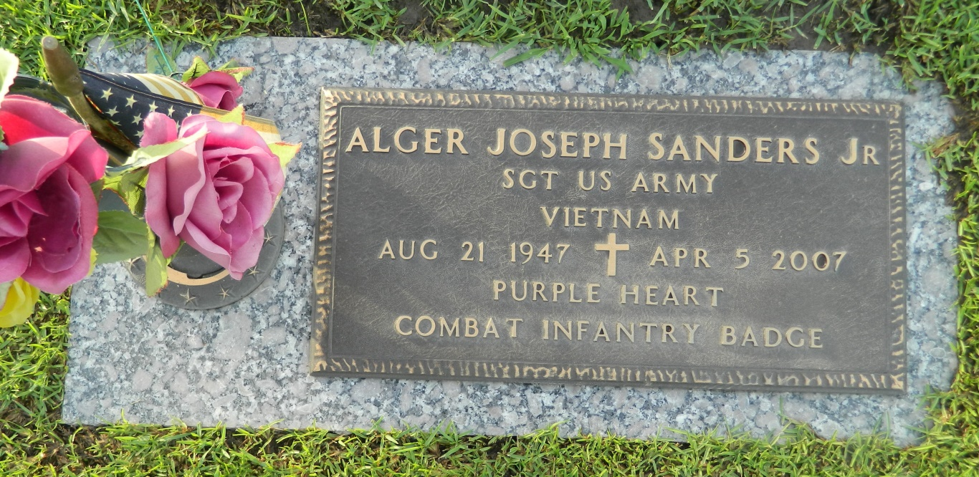

Alger Sanders, Jr. on Thursday, April 5, 2007 at Southeastern Regional Medical Center in Lumberton, North Carolina. Son of Victoria Williams Sanders and the late Alger Sanders, Sr. Husband of Doris Jackson Sanders. Father of Alger Sanders, III, Dwayne Lavalelias, Lyntoga and Orentheo Cayold, Joseph, Darnell and Jarnell Butler and Romond Love. Brother of Bonnie (Donald) Stevenson, Lois (Albert) Short, Veronica Anderson, Cabrini (Carl) James, Wanda, Woodrick and Kevin Sanders, and the late Wayne and Joyce Sanders. Also survived by a host of grandchildren, nieces, nephews, other relatives and friends. Age 59 years, a native of Reserve, LA and a resident of Lumberton, North Carolina.  
  
Relatives and friends of the family, also Pastors, Officers and Members of Mt. Calvary Baptist Church and all neighboring churches are invited to attend the Funeral Service at Mt. Calvary Baptist Church, 127 W. 3rd Street, LaPlace, LA on Saturday, April 14, 2007 at 11:00 AM. Rev. Freddie Howard, Pastor, Officiating. Interment St. John Memorial Garden Cemetery, LaPlace, LA.  
  
SERVICED BY ROBOTTOM

Times-Picayune, The (New Orleans, LA) - Friday, April 13, 2007

Contributed by Jane Edson