Mable E. Sandy
March 12, 1937 – February 28, 2010
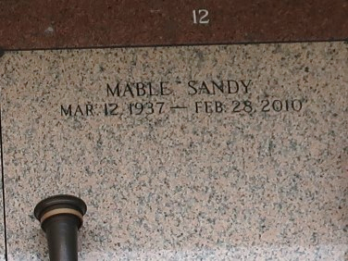

Mable E. Sandy on Sunday, February 28, 2010 at River Region Hospice, River Ridge, LA. Daughter of the late Eva Zeno Gray and Harry Sanders, Sr. Sister of Harry Sanders, Jr. (Lorriane), Ruby Griffin (Robert), Michael Sanders (Doreen), and David Sanders (Laverne) all of Reserve, LA, Rosalind Sanders of LaPlace, LA, the late Ora Lee Sanders Jack and Leroy Sanders, Sr. Niece of Mable McGee of Los Angeles, CA and Emma Sanders of Reserve, LA. Devoted cousin of Marjorie Collins, Mary Ann Carter, Roland Frank, Sr., Ethel Lennix and Ruby Stewart. She had a close bond with her special friends, Eartha Hill, Valencia Green, Clothilde Gauff, Ollie Grover and Shirley Anderson of Clinton, LA. Also survived by a host of nieces, nephews, cousins, other relatives and friends. Age 72 years. A native of LaPlace, LA and resident of Reserve, LA. A retired employee of River Parishes Hospital, LaPlace, LA.
Relatives and friends of the family, also pastors, officers and members of New Pilgrim and Bethlehem Baptist Churches, priest and parishioners of Our Lady of Grace Catholic Church and all neighboring churches and employees of River Parishes Hospital are invited to attend the funeral at New Pilgrim Baptist Church, 107 Pilgrim Drive, Reserve, LA, on Saturday, March 6, 2010 at 11:00 AM. Rev Dr. Forell Bering Pastor, Officiating. Interment St. John Memorial Garden Cemetery, LaPlace, LA. Visitation at the above named church from 9:00 AM until service time. SERVICED BY ROBOTTOM

The Times-Picayune, New Orleans, Louisiana
Mar. 5, 2010

