Patricia Ann Scanlan
February 4, 1949 – December 29, 2017
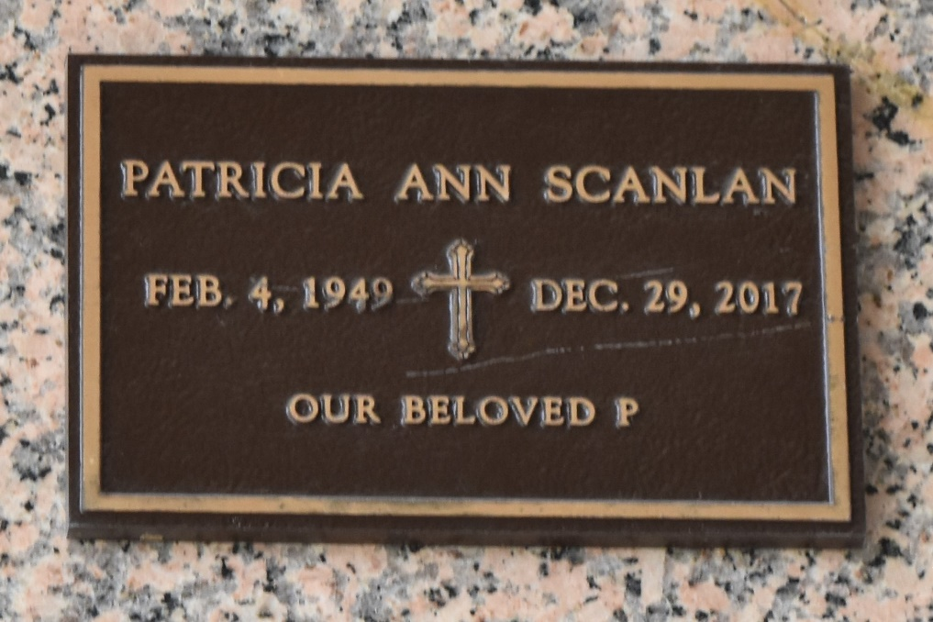

Patricia Ann Scanlan went home to her Heavenly Father on Friday, December 29, 2017, at the age of 68. Patricia was active in her church, Ascension of Our Lord Catholic Church in Laplace, and dearly loved animals. She was the daughter of the late Edward W. Scanlan and Augusta Heavey Scanlan, and is survived by her sisters, Kathleen Mokry, Augusta Scanlan and Marguerite Scanlan Hugo, and by her brother, Robert Scanlan and his wife Debbie. She is also survived by many nieces and nephews.
Relatives and friends are invited to attend the Memorial Mass at Ascension of Our Lord Catholic Church, 1900 Greenwood Drive, Laplace, LA, on Friday, January 5, 2018 at 11:30 a.m., with visitation from 10:00 until 11:00 a.m., and a recitation of the Rosary beginning at 11:00. In lieu of flowers, please consider making a donation in Patricia's memory to Ascension of Our Lord Catholic Church, 1900 Greenwood Drive, Laplace, LA 70068, or to the animal rescue organization of your choice. Arrangements entrusted to the Neptune Society of New Orleans.

The New Orleans Advocate (Louisiana)
Jan. 2 to Jan. 5, 2018

