Annie (Petrosky) Scardina

August 16, 1934 – February 21, 2008

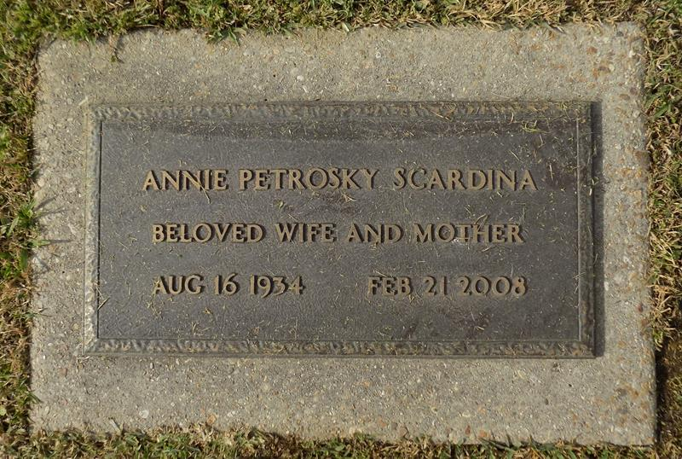

Annie Scardina was born in Republic, PA on August 16, 1934 and passed away on February 21, 2008 in Hammond, LA at the age of 73. She is survived by: 3 daughters, Mary Scardina and husband, Jimmy Keene of Sound Beach, NY, Shirley Scardina of Metairie, JoAnna Scardina and husband, Bennie Slade of Hammond, one son, John Scardina of Raleigh, NC, one brother, Frank Petrosky of Long Island, NY, and 4 grandchildren.

Preceded in death by: her husband, Carlos Scardina, her parents, John & Mary Horwat Petrosky, 5 Brothers, Matthew, John, Jr., Steve, Joseph, & George Petrosky and one sister, Mary Scalia.   
 Visitation will be Monday, February 25, 2008 at Geisler Funeral Home in Ponchatoula from 11:00 a.m. until the service at 12:30 p.m. Interment will follow in St. John Cemetery in Laplace, LA .You may sign an online register book at [www.geislerfuneralhome.net](http://www.geislerfuneralhome.net)

Daily Star, The (Hammond, LA) - Saturday, February 23, 2008

Contributed by Jane Edson