Trey A. Schafer
Unknown - December 4, 2001

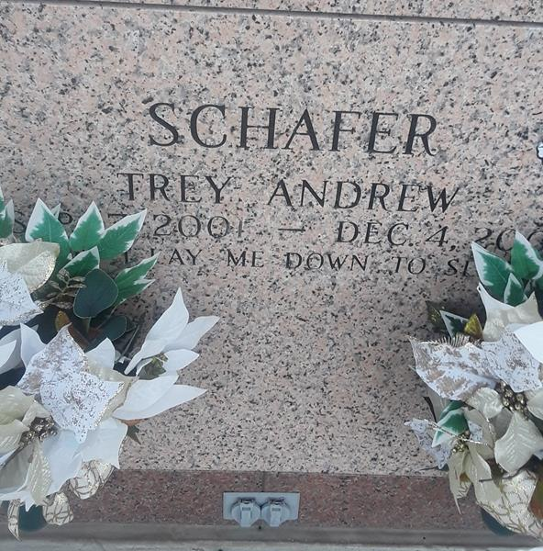

Trey A. Schafer, 11 weeks, a native and resident of LaPlace, died Dec. 4. He was the son of Danny and Kathy Schafer and brother of Kayla and Cody Schafer. He was the grandson of Glen and Kay Freeman and Paul and Pat Schafer. He was also the great-grandson of Nolan and Virginia Walden and the late J.L. and Geneva Freeman.

Services were Dec. 7 at Ascension of Our Lord Catholic Church, LaPlace, with interment at St. John Memorial Gardens, LaPlace.
L'Observateur, LaPlace, Louisiana
December 8, 2001

