Delbert Joseph Schexnayder
February 4, 1949 – December 29, 2017
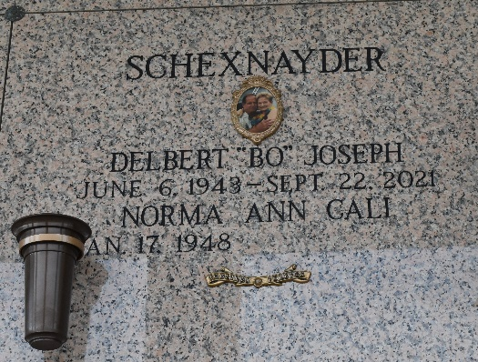

Delbert Joseph "Bo" Schexnayder passed away peacefully at his residence in Ponchatoula, Louisiana on Wednesday, September 22, 2021 at the age of 78. He was born on Sunday, June 6, 1943 in Laplace, Louisiana to Alfred and Malena Schexnayder. Bo retired from Shell Oil where he worked as a welder for 30 years. He was an avid member of the Hammond Recreation Center and the Ponchatoula Lions Club.
Bo is survived by his beloved family: his adoring wife, Norma Ann Cali Schexnayder; children, Danielle Madere St. Martin (Art), and Chantel Madere (Bruce); siblings, Brenda Schexnayder Longaker (Jim) and Gail Schexnayder Falterman; grandchildren, Brandon St. Martin (Brittany) and Maggie St. Martin Bordelon (Justin); great-grandchildren, Hannah and Bryson; and fur baby, Pistache.
Preceded in death by his parents, Alfred and Malena LaBranche Schexnayder; siblings, Dolores Schexnayder Millet and James Schexnayder; and fur babies, Cruiser, Titan, Beau, and Shiloh.
Relatives and friends are invited to attend the Celebration of Bo's Life and Catholic Service in the chapel of LN Hughes Funeral Services, 21400 South I-12 Service Road, Ponchatoula, Louisiana on Tuesday, September 28, 2021 at 11:00 am. The visitation will begin at 9:00 am and continue until 11:00 am.
Inurnment will be held in St. John Memorial Gardens in Laplace, Louisiana at a later date.
LN Hughes Funeral Services of Ponchatoula, Louisiana

