Steven Henry Schott
December 21, 1928 – February 4, 2017
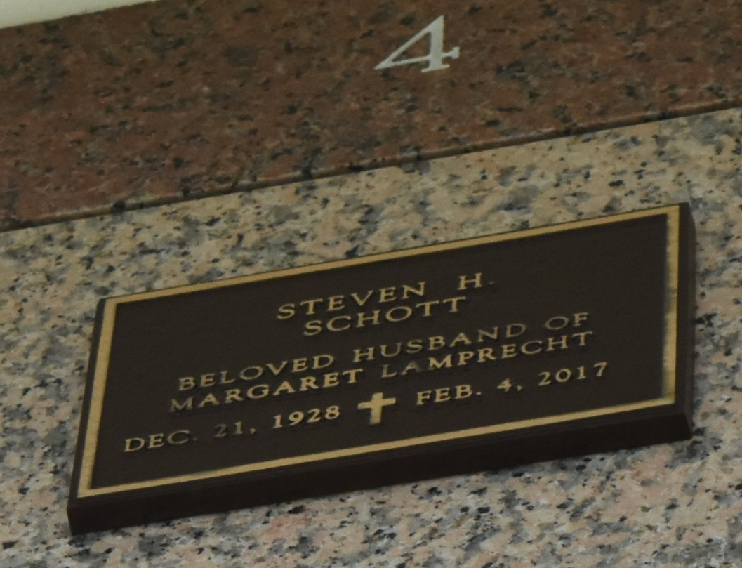

Steven (Stephen) Henry Schott died at his home in LaPlace, LA on February 4, 2017, at the age of 88.
He was born in New Orleans, the fifth of the seven children of Eugenie Oelkers Schott and Bernard I. Schott. He graduated from Jesuit High School in New Orleans in 1946 and entered the Society of Jesus, the Jesuits, shortly afterward. He was a Jesuit lay brother for 25 years. He worked as a master electrician and in other construction-related activities for his entire adult life until his retirement.
He was predeceased by his beloved wife, Margaret Lamprecht Schott, his parents, his only sister, Rosemary Schott Stevens and his two eldest brothers, Arthur O. Schott and Bernard J. Schott.
He is survived by his other three brothers, Reverend Paul W. Schott, S.J. of Grand Coteau, LA, Judge Patrick M. Schott (retired) of New Orleans, LA, and retired professor Matthew J. Schott, PhD of Lafayette, LA, and a host of nieces and nephews.
Relatives and friends are invited to a Mass of Christian Burial at Ascension of Our Lord Catholic Church, 1900 Greenwood Dr., LaPlace on Monday, February 13, 2017 at 11:00 a.m. Visitation at the church from 10:00 a.m. to 11:00 a.m. Interment will follow in St. John Memorial Gardens Cemetery, 2205 W. Airline Highway in LaPlace. The family expresses deep appreciation to Leah Hoover, RN, and Kelly Christopher for caring for Steve in his last illness and especially to Randy Lewis who took care of Steve for the past few years.

Millet-Guidry Funeral Home, LaPlace, Louisiana

