Anna Mae (Perilloux) Schutz
July 17, 1923 – February 29, 2016
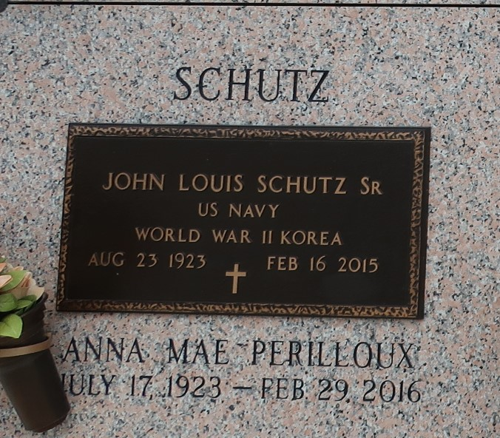

Anna Mae Perilloux Schutz passed away on Monday, February 29, 2016 at the age of 92. She was a native and life long resident of LaPlace, LA. Beloved wife of the late John Louis Schutz Sr. Mother of Carl Schutz (Audrey), Karen Schutz and Wendy Cromley (Barry) and the late John Louis Schutz, Jr. (Milly). Daughter of the late Albertine Simoneaux and Lucien Perilloux. Sister of Dolores Millet, Leonard Perilloux, Brent Perilloux and the late Calvin Perilloux, Raymond Perilloux and Ronald Perilloux. Grandmother of John Milton, Amy, Polly, Sally, Carl Jr., Stacy, Lee, Jill, Scott, Stephanie, Crystal and Carli. Also survived by 15 great-grandchildren and many nieces and nephews.

Relatives and friends are invited to attend the Funeral Mass at St. Joan of Arc Catholic Church, 529 W. 5th St., LaPlace on Thursday, March 3, 2016 at 12:00 p.m. Visitation at the church from 10:00 a.m. until 12:00 p.m. Interment in St. John Memorial Gardens Cemetery. Arrangements by Millet-Guidry Funeral Home.

The New Orleans Advocate, Louisiana
Feb. 29 to Mar. 3, 2016

