John Louis Schutz Sr.
August 23, 1923 – February 16, 2015
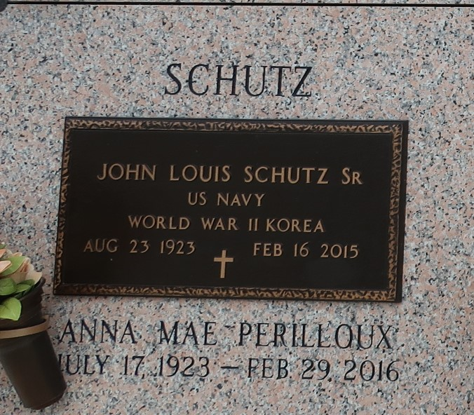

John Louis Schutz, Sr. passed away on Monday, February 16, 2015, at the age of 91. He was born in Waelder, TX, and resided in LaPlace, LA. Mr. Schutz proudly served our country in the U.S. Navy during WW II and during the Korean Conflict.
Beloved husband of Anna Mae Perilloux Schutz. Father of Carl Schutz (Audrey), Karen Schutz and Wendy Cromley (Barry) and the late John Louis Schutz, Jr. (Milly). Son of the late Agnes Jurek and John Christopher Schutz. Brother of Dorothy Britt, Ernestine Hohensee and the late Eugene Schutz, Frances Wulf and Christine Morris. Grandfather of John Milton, Amy, Polly, Sally, Carl Jr., Stacy, Lee, Jill, Scott, Stephanie, Crystal and Carli. Also survived by 15 great-grandchildren and many nieces and nephews.
Relatives and friends are invited to attend the Funeral Mass at St. Joan of Arc Catholic Church, 529 W. 5th St., LaPlace, on Friday, February 20, 2015 at 12:00 p.m. Visitation will begin in church at 10:00 a.m. Interment in St. John Memorial Gardens Cemetery. Arrangements by Millet-Guidry Funeral Home. To view or sign the online guest book, please visit www.milletguidry.com.
The New Orleans Advocate, Louisiana
Feb. 18 to Feb. 21, 2015

