Elmore P. Scioneaux
July 17, 1923 – February 29, 2016
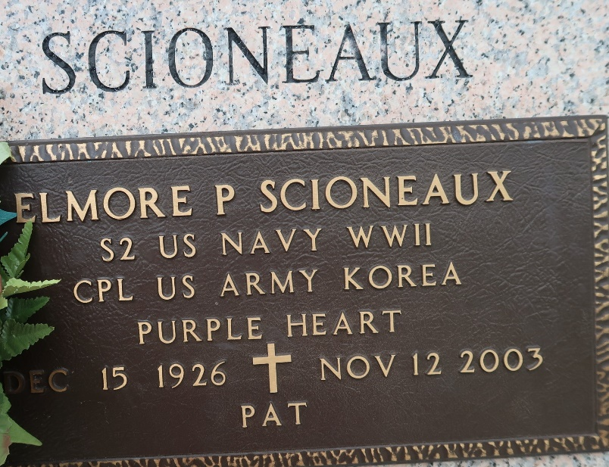

Elmore ''Pat'' Scioneaux on Wednesday, November 12, 2003 at 8:55 AM. Beloved husband of the late Shirley Timberlake Scioneaux. Father and father-in-law of Johnny and Peggy Robichaux McKinney and George ''Cootie'' and Ann Bennett McKinney. Grandfather of Shawn, Misty, Jennifer, Bonnie, Bridget, and Amanda McKinney. Great grandfather of Heidi, Heather and Heath McKinney. Son of the late Pascal and Clara Landry Scioneaux. Brother of the late Pascal Jr., and Etienne Scioneaux, Jeanne Rhodes and Estelle Mabile. Brother-in-law of Harvey, David and Stanley Timberlake, Betty Huber, Joyce Rushing and Mickie Sullivan. Caring uncle and PAW PAW to many loved ones; Cassidy, Jerome, Crystal, Wesley, Alicia and Jessica. Retired from Kaiser Aluminum and Bully's Half Way House. Age 76 years, a native of Reserve, LA and a resident of LaPlace, LA for the past 44 years.
Relatives and friends of the family are invited to attend services. Visitation at Millet-Guidry Funeral Home, 2806 W. Airline Hwy., LaPlace, LA on Sunday, November 16, 2003 from 5pm to 10pm and on Monday from 8am to 10am. Followed by Religious Services in the funeral home chapel. Burial in St. John Memorial Gardens, LaPlace, LA. Special thanks to Mickie and Armond Sullivan for their love and care.

The Times-Picayune, New Orleans, Louisiana
Nov. 14, 2003

