Tammy (Heltz) Scontrino
May 31, 1959 – January 27, 2001
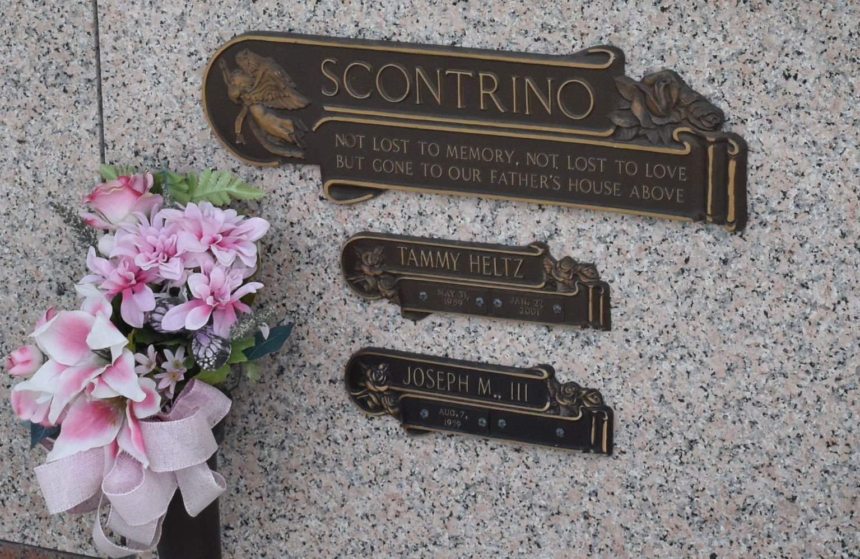

LAPLACE – Tammy Heltz Scontrino, 41, a native of Garyville and resident of LaPlace for 23 years, died Jan. 27.
She was the wife of Joey Scontrino III and mother of Nicole and Derek Scontrino. She was also the daughter of the late Ernest Sr. and Elma Heltz and sister of Gina Krause, Pamela Montz and Ernest Jr. and Christopher Heltz.
Services are today at 10 a.m. at Ascension of Our Lord Catholic Church, LaPlace, with interment at St. John Memorial Gardens, LaPlace. Visitation starts at 8 a.m.

Unknown source

