Sadie Mae (Bailey) Scott
October 13, 1924 – September 6, 2020
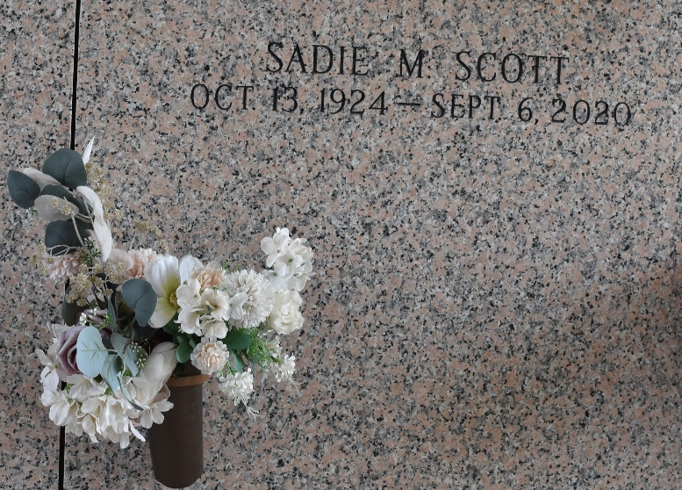

Sadie Mae Bailey Scott on Sunday, September 6, 2020 at her home in LaPlace, LA. Daughter of the late Peter and Lena Mosely Bailey, wife of the late Harry Scott, Sr., mother of Harry Scott, Jr. (the late Deborah), Rev. Tyrone Scott (Prophetess Lucretia), Gwendolyn Lena Scott, Beverly Scott, the late Linda Jean Scott Martin, Betty Jo Scott Bailey, Roger Kay, Sr. (Darlene), Gloria and Claudia Scott, sister of the late Rose Mae Bailey Diggs, Louellen Bailey Brown and Lawrence Bailey, Sr., and niece of the late Louellen Williams. Also survived by 19 grandchildren, over fifty great-grandchildren, over 60 great great-grandchildren, two sons-in-law and a host of nieces, nephews, cousin, other relatives and friends. Age 95 years, a native of Norco, LA and resident of LaPlace, LA.
Relatives and friends of the family, also pastors, officers and members of Greater Good Hope Baptist Church and New Wine Christian Fellowship are invited to attend the funeral service at New Wine Christian Fellowship, 1929 West Airline Highway, LaPlace, LA on Friday, September 11, 2020 at 11:00 a.m. Pastor Neil Bernard and Rev. Tyrone Scott, Pastor of Greater Good Hope Baptist Church, Officiating. Interment: St John Memorial Garden, LaPlace, LA. Visitation at the above named church from 9:00 a.m. until service time ONLY. Everyone in attendance is required to wear a mask and practice social distancing because Covid-19 is still in our midst. Serviced by Robottom.

The Times-Picayune, New Orleans, Louisiana
Sep. 9 to Sep. 11, 2020

