Virgil Scott, Pastor
October 14, 1957 – July 3, 2010
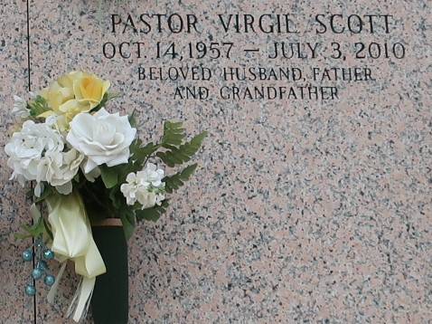

Rev. Virgil Scott departed this earthly life and entered into eternal rest Saturday, July 3, 2010 at Ochsner Medical Center of Jefferson, LA. Son of Marian and Joseph Scott, Sr. of Paulina, LA. Beloved husband of Marilyn M. Scott of LaPlace, LA. Loving father of Delwellyn "Jennifer" Scott, Dequincy "Ereka" Scott and Diatania "Kurk" Scott-Paul. Brother of Rev. Joseph "Gladys" Scott, Jr., Patti "Ronald" Scott-Degree, Bruce Wayne Scott and Gail Washington. Grandfather of Isaiah, Elijah, Noah, and Amayah Scott. Son-in-law of Maudrey Mae Johnson. Also survived by a host of aunts, uncles, other relatives and friends. Rev. Scott was the devoted Pastor of Pleasant Hill Baptist Church of Convent, LA.
Relatives and friends of the family, also pastors, officers and members of First Community, Antioch Baptist Church of Lutcher, LA, Pleasant Hill Baptist Church of Convent, LA and all neighboring churches are invited to attend the Funeral Services on Saturday, July 10, 2010 at 11:00 a.m. at First Community Antioch Baptist Church, 10860 Hwy. 3125 Lutcher, LA where the Pastor is the Rev. Ferdinand Gaines, Jr. Host Pastor Joseph Scott, Jr., officiating. Interment in St. John Memorial Gardens of LaPlace, LA. Visitation will be at the above named Church from 9:00 a.m. until service time. BARDELL'S MORTUARY of Mt. Airy, LA in charge. Information: (985) 535-6837.

The Times-Picayune, New Orleans, Louisiana
July 9, 2010

