Laura Mae (Colbert) Selders
January 4, 1935 – August 14, 2021
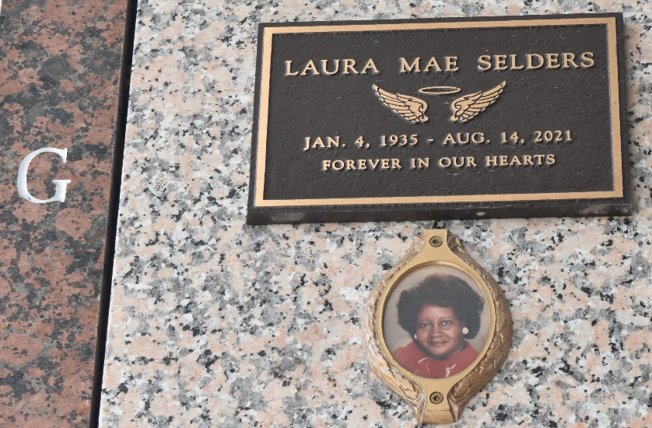

Laura Mae Selders peacefully passed away on Saturday, August 14, 2021 at the age of 86, at Ochsner Medical Center-Kenner, LA. Daughter of the late Albert Colbert, Sr. and the late Clara August Colbert. Wife of the late Wilbert Selders, Sr. Beloved mother of Iris Lynn (M.C.) Hunter, Clara (Bernard) Lewis, Barolyn Selders, Carl Lewis (the late Lubertha) and the late Keith and Kevin Selders. Sister of Leonard Lee Colbert (Four Corners, LA), Roy Nathaniel (Alice) Colbert (Lafayette, LA), Gloria Washington, Amelia Colbert (New Orleans), Louisa Williams (Jeanerette, LA), and LuAda (Larry) Washington (Four Corners, LA) and the late Pearl Colbert Teno, Cora Bell Bryant, Marva Ann Colbert Hines, Frank Colbert, Sr., Albert Colbert, Jr. and Darrell Colbert, Sr. sister-in-law of Elnora Colbert (Jeanerrette, LA). Also survived by 14 grandchildren, 30 great grandchildren and a host of nieces, nephews, cousins, and other relatives and friends. A native of Four Corners, LA and a resident of LaPlace, LA.
Relatives and friends of the family, also Pastor, Officers & Members of Tchoupitoulas Chapel, all neighboring churches and St. John Parish School Board are invited to attend a Celebration of Life on Saturday August 21, 2021, at 11:00 A.M. at Tchoupitoulas Chapel, 1022 LA-44 Reserve, LA. Rev. Lionel Murphy, Officiant. In accordance with the CDC guidelines for COVID-19 all in attendance must wear a mask and practice social distancing. Visitation at the above named church at 9:00 A.M. until time of service. Final arrangements entrusted to Patrick H. Sanders Funeral Home & Funeral Directors, Inc. For information 985-3659-1919.

The Times-Picayune, New Orleans, Louisiana
August 18-21, 2021

