Lubertha W. Selders
December 7, 1947 – April 1, 2015
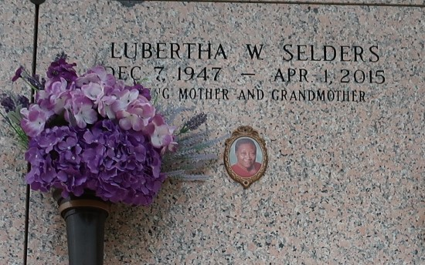

Lubertha Selders, age 67, passed away on Wednesday, April 1, 2015. Mother of Bridget Coco, Bernard, Darren, Wilfred, Kim, Julia, and Dina Lewis. Also survived by a host of other relatives and friends.
Funeral service on Saturday, April 11, 2015 at Beech Grove Baptist Church, 117 Beech Grove Dr, Reserve, LA 70084 at 10:00am. Visitation at 9:00am. Rev. Wesley Anderson Sr., Pastor, Rev. Jeff Patterson officiating. Internment in St. John Memorial Gardens, Laplace, LA. Service Entrusted to Hobson Brown Funeral Home Garyville, La 70051 985-535-2516.

The Times-Picayune, New Orleans, Louisiana
August 18-21, 2021

