Elsie May (Harris) Sellars
July 21, 1924 – August 5, 2010
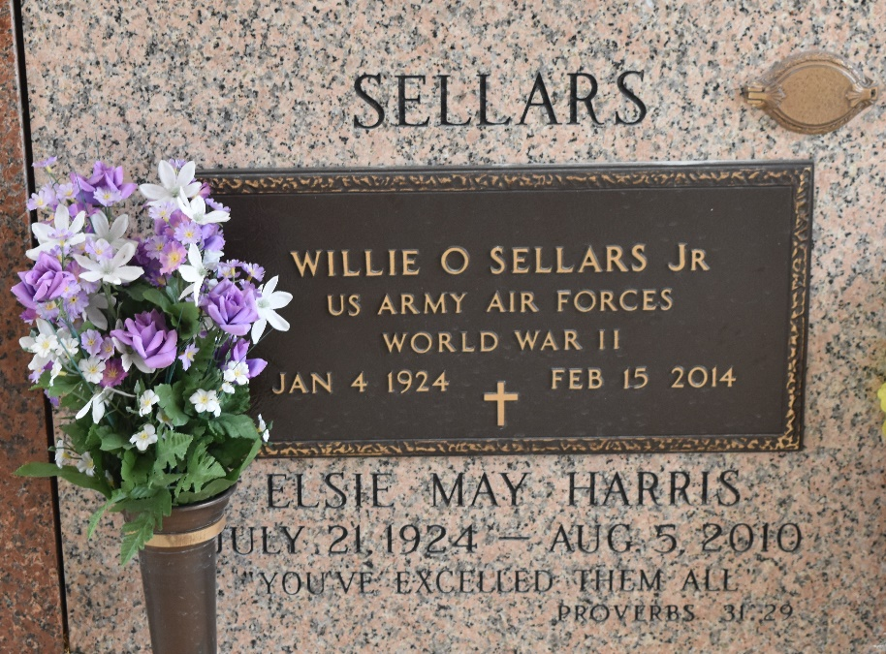

Elsie Harris Sellars passed away on Thursday, August 5, 2010. Beloved wife of Willie Sellars. Mother of Glenn Sellars and wife Kathy, Patrick Sellars and wife Billie and William Sellars. Also survived by 12 grandchildren and 1 deceased and 13 great-grandchildren. Daughter of the late Charles and Evelyn Harris. Age 86. A native of England and a resident of LaPlace, La. for the past 43 years.

Relatives and friends are invited to attend services. Visitation at Millet-Guidry Funeral Home, 2806 W. Airline Hwy. LaPlace, La. on Tuesday, August 10, 2010 from 9:00 am to 11:00 am. Followed by Religious Services at the Funeral Home Chapel 11:00 am. Burial in St. John Memorial Gardens Cemetery, LaPlace, LA.

The Times-Picayune, New Orleans, Louisiana
August 7, 2010

