Willie O. Sellars Jr.
January 4, 1924 – February 15, 2014
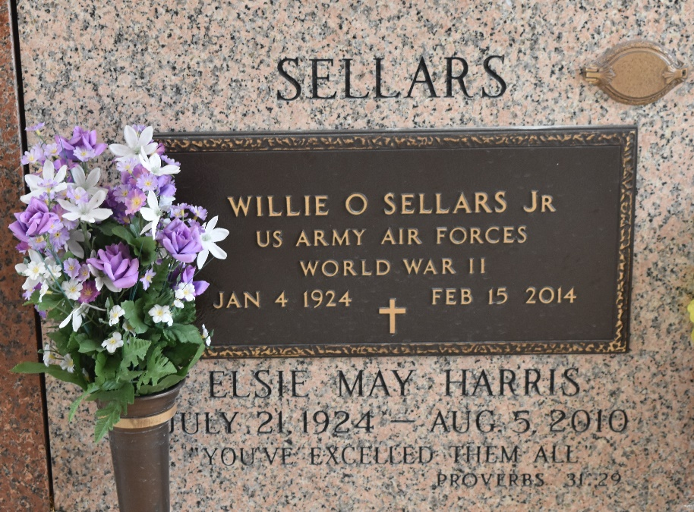

Willie O. Sellars Jr., died on Saturday February 15, 2014 from complications of a heart attack. Beloved husband of the late Elsie Harris Sellars. Father of Glenn Sellars (Kathy), Patrick Sellars (Billie) and William Sellars. Also survived by 12 grandchildren, 1 deceased and 21 great-grandchildren. Son of the late Will and Bessy Willoughby Sellars. He served in the Army Aircorp during WWII, met and married Elsie Mae Harris in England, came back to USA and raised 3 sons with a very firm, but loving hand. We had a good father and we are blessed. Age 90. A native of NC and a resident of LaPlace, LA.

Relatives and friends are invited to attend services. Visitation at Millet-Guidry Funeral Home, 2806 W. Airline Hwy., LaPlace, LA on Wednesday February 19, 2014 from 9:00am to 11:00am,followed by Religious Services In the Funeral Home Chapel at 11:00am. Burial in St. John Memorial Gardens, LaPlace, LA.

The Times-Picayune, New Orleans, Louisiana
February 16-19, 2014

