Gibson Sewell Jr.
May 30, 1942 – November 29, 2021
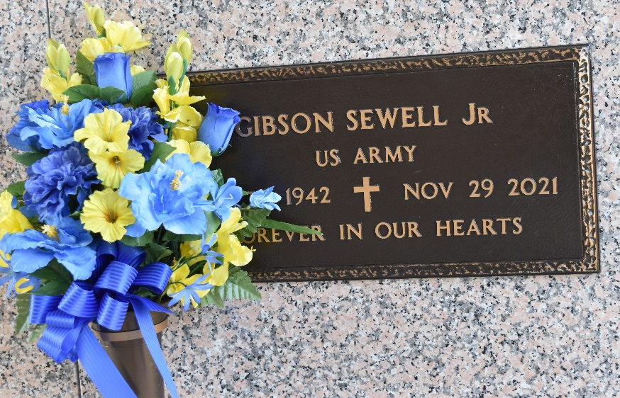

Gibson Sewell, Jr. passed away on Monday, November 29, 2021 at Ochsner River Parishes, LaPlace, LA. Son of the late Stazzie Yearby and Gibson Sewell, Sr. Wife of Evelyn Alexander Sewell. Father of Nina Hudson (Parnell), Juan Sewell (Emma), Gretchen Sewell-Brown (Terrence), Reshia Johnson (Chavier, Sr.), Corey Sewell (Jenna), Alexander Sewell (Jessica) and the late Trisch Sewell. Brother of Renee Collins, Sharon Simmons, Joseph Barnes (Sandra), the late Walter Sewell, Bobby Sewell and Rose Elmore. Also survived by a host of grandchildren, great grandchildren, great great grandchildren, nieces, nephews, cousins, other relatives and friends. Age 79 years. A native of Olla, LA and a resident of LaPlace, LA. He is a veteran of the US Army.
Relatives and friends of the family, also pastors, officers and members of Beech Grove Baptist Church and all neighboring churches and Doctors and Staff of Ochsner Medical Center are invited to attend the funeral service at Beech Grove Baptist Church, 117 Beech Grove Dr., Reserve, LA on Saturday, December 4, 2021 at 3:00 PM. Rev. Cory Batiste, Pastor, Officiating. Interment St. John Memorial Garden Cemetery, LaPlace, LA. Visitation at the above named church from 2:00 PM until service Only. Everyone in attendance should wear a mask and practice social distancing. Serviced by Robottom.
The Times-Picayune, New Orleans, Louisiana
December 1-4, 2021

