Audrey Mae Sharlow
June 25, 1941 – March 20, 2015
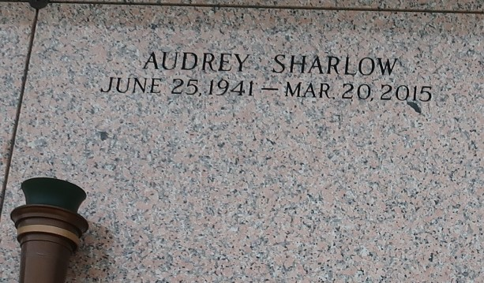

Audrey Mae Sharlow on Friday, March 20, 2015 at Ochsner Kenner, Kenner, LA. Daughter of the late Louise Mercier and Olebar Sharlow Mother of David Sharlow, Sr., Steven Sharlow, Desiraee Sharlow Jones, Tara Sharlow Wilson and Travis Sharlow Sister of Catherine S. Anderson, Vera S. Martin, Crystal Sharlow, the late Joseph Carter and Wilman Sharlow Also survived by 9 grandchildren, 11 great grandchildren and a host of nieces, nephews, cousins, other relatives and friends. Age 73 years. A native and resident of LaPlace, LA.

Relative and friends of the family, also priest and parishioners of Our Lady of Grace Catholic Church and all neighboring churches are invited to attend the Funeral Mass at Our Lady of Grace Catholic Church, 772 Hwy 44 (River Road), Reserve, LA on Saturday, March 28, 2015 at 10:00 AM Father Christopher Amadi, Celebrant Interment St John Memorial Garden Cemetery, LaPlace, LA. Visitation at the above named church from 8:15 AM until Mass time. Rosary at 9:15 AM SERVICED BY ROBOTTOM.
The Times-Picayune, New Orleans, Louisiana
March 25-27, 2015

