David J. Sharlow Jr.

July 20, 1985 – December 30, 2012

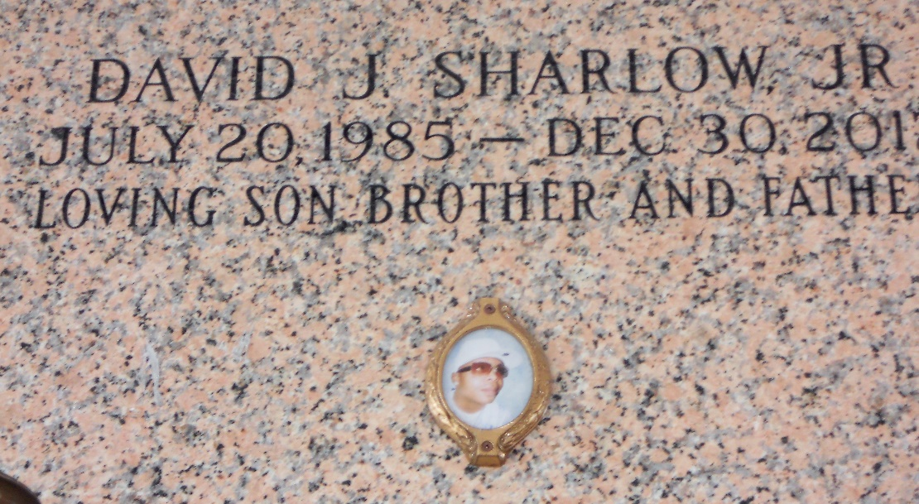

Photo by Team T-Lo

David J. Sharlow Jr. departed this life on Sunday, December 30, 2012. Son of David Sr. and Norma Sharlow. Brother of Dwight, Dwayne, Dawanda, and Delisa Perrilloux, David Hamilton and Davinna Sharlow. Also survived by a devoted friend Ashley Diggs, nieces, nephews, other relatives and friends.

Funeral Service will be held on Monday, January 7, 2013 at 10:00am at Providence #2 Baptist Church, 152 Union Ln. Montz, LA. Visitation from 9:00am until service time. Internment in St. John Memorial Gardens, LaPlace, LA. Rev. Donald Brown Sr. Pastor officiating. Service Entrusted To Hobson Brown Funeral Home 134 Daisy St/P.O. Box 61 Garyville, La (985) 535-2516.

The Times-Picayune, New Orleans, Louisiana

January 4-6, 2013