Nell (York) Shaughnessy
April 15, 1918 – January 16, 1999

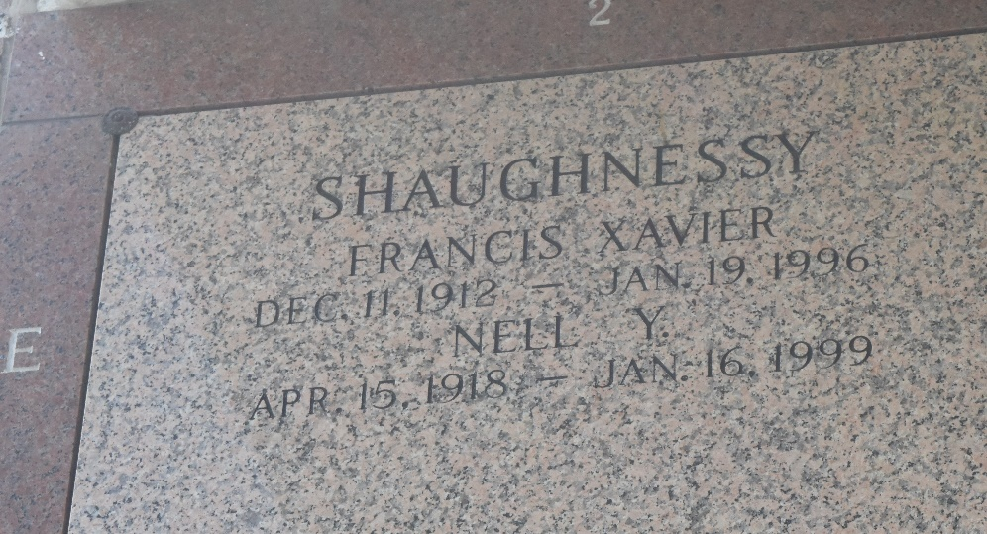

PONCHATOULA - Nell Brown York Shaughnessy, 80, a native of Sicily Island and a resident of Hammond, died Jan. 16. She was the wife of the late Francis Xavier Shaughnessy and mother of Jean Vaughn, Kathleen Spencer and Michael and Francis X. Shaughnessy Jr. She was also the daughter of the late Zeb and Henry Brown York and sister of the late Jean Batey and twin brother, Zeb York Jr. She is also survived by 12 grandchildren and eight great-grandchildren.

Services are Jan. 21 at 10 a.m. in the chapel of Harry McKneely & Son Funeral Home, Ponchatoula, with interment at St. John Memorial Mausoleum, LaPlace. Visitation starts today from 6 p.m. to 10 p.m. and tomorrow at 8 a.m.
L'Observateur, LaPlace, Louisiana
January 20, 1999

