Hazel (Rush) Shoemaker

1925 – April 29, 2003

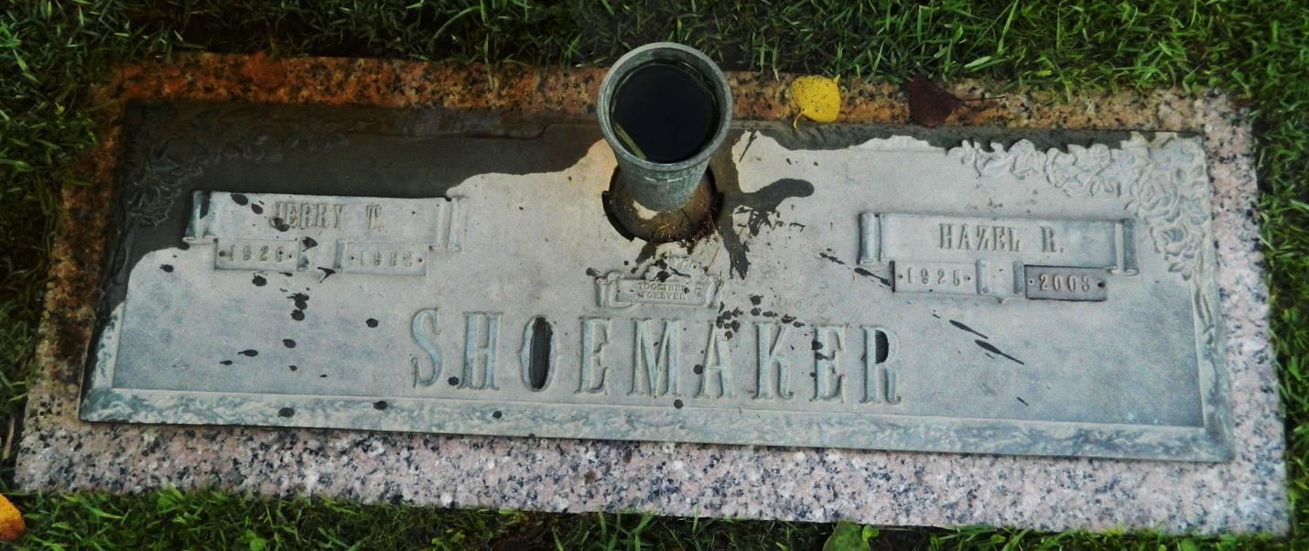

Hazel Rush Shoemaker on Tuesday, April 29, 2003 at 2:47 PM. Beloved wife of the late Jerry Shoemaker. Mother of Rickie and the late David Shoemaker. Daughter of the late Edward and Armilea Pierce Rush. Sister of Audi Bennet, Barney Rush and the late Delsi Daniels, Edna Guillot, Emma, Herbie Lee, Herman, Carnie, Billy and J.D. Rush. Stepsister of Olla and Jessie. Age 77 years. A native Rapides Parish and a resident of Laplace, LA for the past 30 years.  
  
Relatives and friends of the family are invited to attend visitation at Millet Guidry Funeral Home, 2806 W. Airline Hwy. Laplace, LA on Saturday, May 3, 2003 from 11:00 AM to 1:30 PM followed by Religious Service in the funeral home chapel at 1:30 PM. Burial in St. John Memorial Garden in Laplace, LA.

Times-Picayune, The (New Orleans, LA) - Thursday, May 1, 2003

Contributed by Jane Edson