Andre K. Simmons
July 4, 1968 – Sep tember 15, 2021
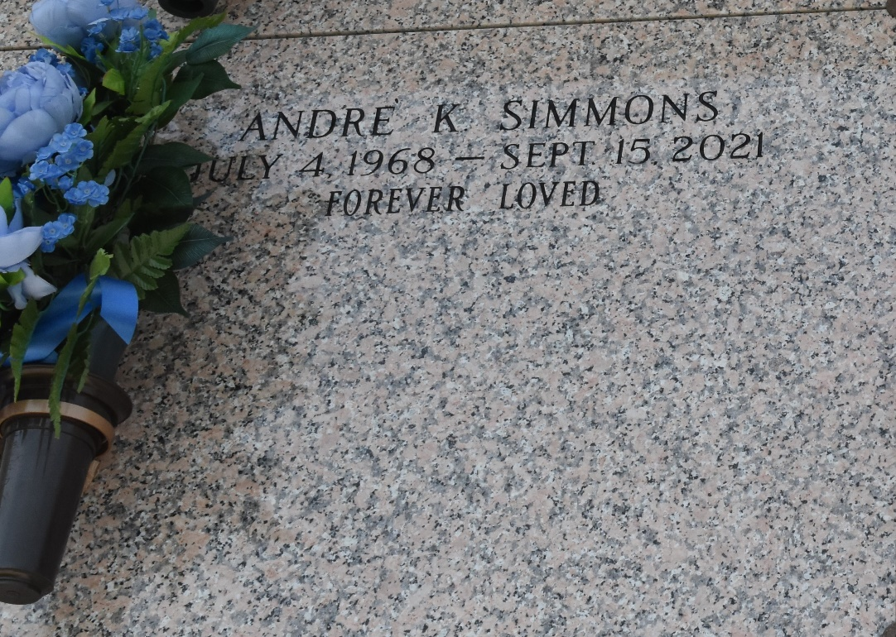

Andre' Kirk Simmons, Sr., age 53, of LaPlace, LA went home to be with his Lord and Savior on Wednesday September 15, 2021. He was born on July 4, 1968 in New Orleans, LA. He is survived by his mother, Verlina Dickerson Simmons; four children, Kyron Downing, TaJuan Johnson, Raven Simmons, and Andre' Kirk Simmons, Jr.; his siblings, Pastor Carla Ceaser Jones (Barry), Galyn Simmons Jones, and Mose Simmons, Jr. (Alicia); and one grandson, Khalil. He is also survived by aunts, Olivia D. Gordon, Gertie D. Polk (Louis), Irene D. Jasmine (Calvin), Brenda D. Pierce, Pamela M. Dickerson, and Gloria S. Fields; uncles, William Dickerson (Jennifer), Whitney Dickerson (Sandra), and Floyd Dickerson; His special nephew, Colin Andre Ceaser; cousins, Ryan, Deandre, and Trae Dickerson, and Claude Gordon; Friends, Randell Joseph, Zolton Johnson, Chris Staggers, Kenneth August, and Ben Johnson, among many others.
He was preceded in death by his father, Mose Simmons, Sr.; grandparents, William and Edna Clark Dickerson and Nathanial and Louiza Young Simmons; aunts, Francis Howard, Helen Simmons, Alma Hayes, Delores Simmons; uncles, Preston Joseph, Joseph Simmons, Charles Gordon and Claude Gordon, Jr.; brother-in-law, Lawrence Jones; and cousins, Kerrick Gordon and Derron Parquet.
Andre' "Dre" was a Halogen Welder who travelled extensively doing what he loved. He was truly loved by many and will be greatly missed.
Due to COVID pandemic, face masks are required to be worn for the duration of the viewing and funeral services. Family and friends are invited to attend the Homegoing Celebration at Bethlehem Baptist Church, 146 E. 20th Street, Reserve, LA on Saturday, September 25, 2021 at 10:30 am. Visitation will be from 9 a.m. until service time. Interment will be at St. John Memorial Gardens. Arrangements are entrusted to Bardell's Mortuary Mt. Airy, LA. Information: (985) 535-6837.

The Times-Picayune, New Orleans, Louisiana
September 24-25, 2021

