Dorothy (Joachin) Simon
August 18, 1922 – January 21, 2005
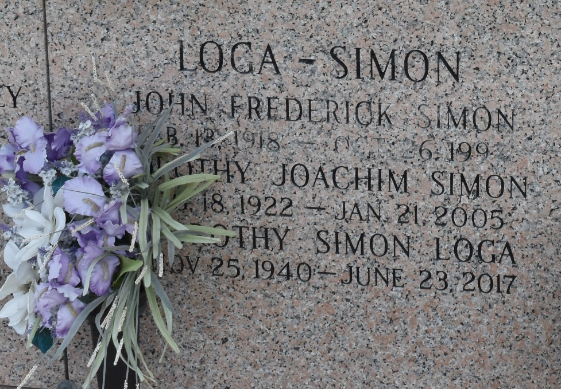

Dorothy Joachim Simon, Age 82, Died On Friday, January 21, 2005 At 11pm.
Beloved Wife Of The Late John F. Simon. Mother Of Dorothy S. Loga And Gaynell S. Melerine. Daughter Of The Late Marie Dauterive Joachim And Albert A. Joachim. Sister Of The Late Albert J. Joachim And Helen Soniat. Grandmother Of Keith H. Loga, Sr. And Randy And Kevin Melerine. Also Survived By 7 Great Grandchildren. Mrs. Simon Was A Former Resident Of St. Bernard Parish And A Resident Of Laplace, LA For The Past 7 Years.
Relatives And Friends Of The Family, Also Members Of The American Legin Auxillary, Spillway Unit 195, Employees Of Bisso Towboat Co., Inc., Surfacejet, Boes Corp., Cheramie Marine, LLC And Former Employees Of Ogden Foods Are Invited To Attend The Funeral Services From H.C Alexander Funeral Home, 821 4th St., Norco, LA, On Tuesday, January 25, 2005, At 11am. Lutheran Services Will Be Held In The Parlor. Interment In St. John Memorial Gardens, Laplace. LA. Visitation From 6:00pm Until 10:00pm Monday And After 8:00am Until The Time Of Service On Tuesday.

The Times-Picayune, New Orleans, Louisiana
January 24, 2005

