Bruce M. Simoneaux
July 25, 1943 – June 14, 2014
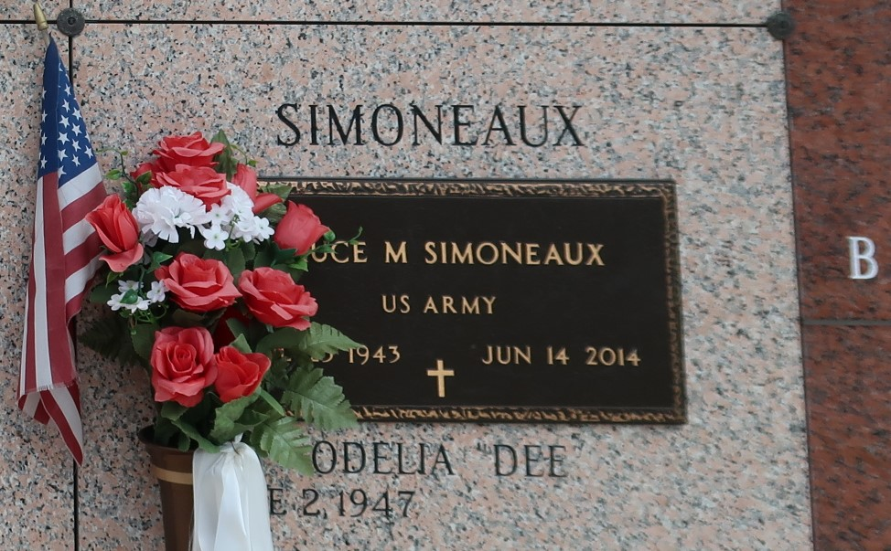

Bruce M. Simoneaux died on Saturday, June 14, 2014. Beloved husband of Odelia "Dee" Simoneaux for 46 yrs. Father of Scott Simoneaux (Rebecca) and Denise Bertrand (Brian). Grandfather of Travis, Jr., and Paxton McDuffie, Evan and Eden Simoneaux, Amanda and Andrea Bertrand. Son of the late Frank Alberic and Elise Simoneaux. Son-in-law of Edmond "Buddy" Waguespack and the late Olga Waguespack. Brother of Lloyd (Ransome), Milton (Betty) and Kenneth (Marilyn) Simoneaux, Gerry Faucheux (Weff), Beverly Louque (Alvin), Joyce Smith and the late Larry Simoneaux (Jean) Brother-in-law of the late Ronald Waguespack.
He retired from Shell Oil Refinery, an Army Veteran, a former member of The LaPlace Volunteer Fire Dept., current member of Ascension of Our Lord Knights of Columbus Council 9623 and 4th Degree Knight of the Archbishop Blenk Assembly 318 and a recipient of the St. Louis Medallion. Age 70. A native New Sarpy and resident of LaPlace, LA.
Relatives, friends and AOL faculty, staff and parents are invited to attend services. Visitation at Ascension of Our Lord Catholic Church, 1900 Greenwood Dr., LaPlace, LA on Tuesday June 17, 2014, from 5:00pm to 8:00pm and on Wednesday from 9:00am to 11:00am, followed by Mass at 11:00am. Burial in St. John Memorial Gardens. Arrangements by Millet-Guidry Funeral Home, LaPlace, LA.
The New Orleans Advocate, Louisiana
Jun. 16 to Jun. 17, 2014

