Evan Michael Simoneaux
August 30, 1999 – April 2, 2017
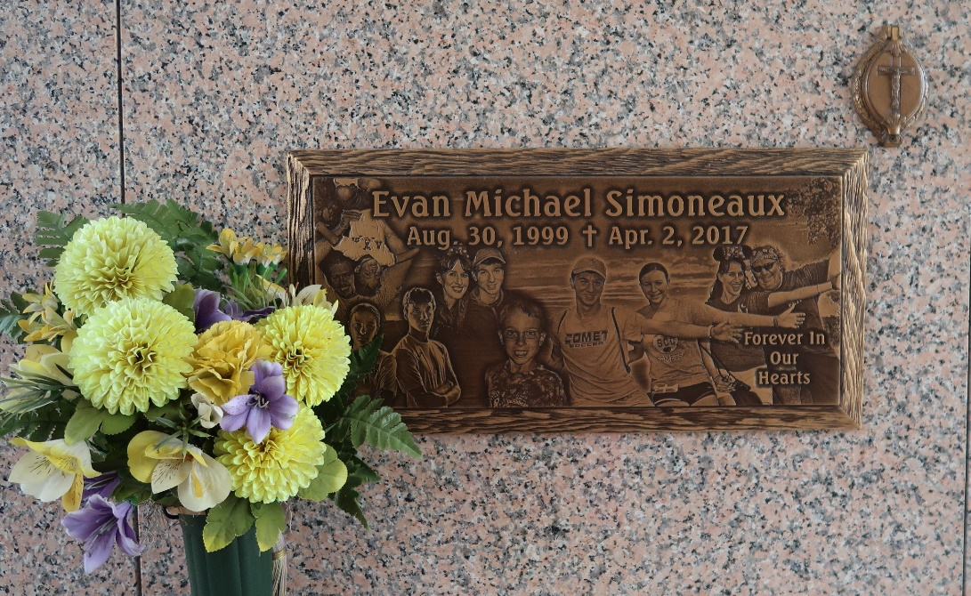

Evan Michael Simoneaux passed away on Sunday, April 2, 2017 at the age 17. He was a native and lifelong resident of LaPlace, LA. Evan was a senior at St. Charles Catholic High School where he was a member of the Beta Club and Soccer Team. He also served as an altar server for St. Joan of Arc Catholic Church.
Beloved son of Scott Michael and Rebecca Acosta Simoneaux. Brother of Eden Simoneaux. Grandson of Odelia Simoneaux and the late Bruce Simoneaux and the late Leroy and Nancy Acosta. Nephew of Kelly and Daryl Turner and Denise and Brian Bertrand. Cousin of Sophia and Dylan Turner and Travis and Paxton McDuffie. Also survived by many friends and other relatives.
Relatives and friends are invited to attend the visitation at St. Joan
of Arc Catholic Church, 529 W. 5th St., LaPlace on Friday, April 7, 2017 from 8:00 p.m. to 10:00 p.m. and on Saturday, April 8, 2017 from 9:00 a.m. to 11:00 a.m. The Funeral Mass will immediately follow the visitation at 11:00 a.m. Interment in St. John Memorial Gardens Cemetery.
Millet-Guidry Funeral Home, LaPlace, Louisiana

