Sandra B. Simoneaux
August 30, 1999 – April 2, 2017
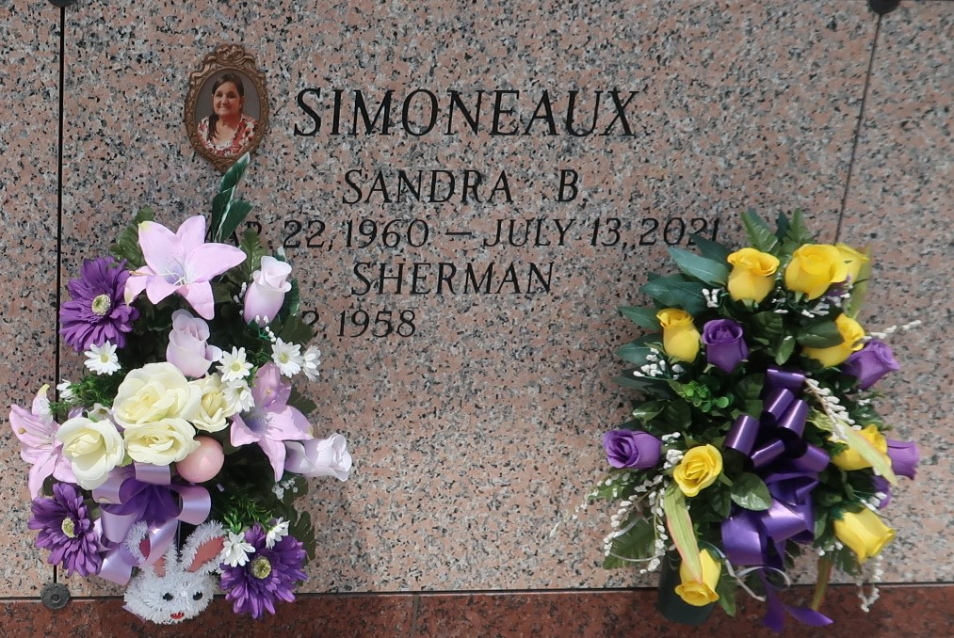

Sandra Ann Simoneaux, a resident of St. John Parish, passed away on July 13, 2021 at the age of 61. She had a strong heart. Sandra loved cooking, making candy, crafting and sewing. She had a special place in her heart for her grandchildren and her chihuahua Sugar.
She is survived by her husband, Sherman Simoneaux, Jr; daughters, Melissa, Felicia, Amanda; sons, Micheal and Sherman III; her brothers and sisters, Liz, Martha, Bubba, William, Dean, Carl, and Steven Paul; her 14 grandchildren, Damon, Dylan, Gunner, Buck, Drake, Mikie, RyLeah, Gabrielle, Jeremy, Jacob, Destiny, Blake, Madison, and Nicholas; her step-grandchildren, Elizabeth, William, and Reality.
She is preceded in death by her parents, Hubert and Mary Ann Bourgeois; daughter, Laura; father-in-law, Sherman Simoneaux; mother-in-law, Yvonne Tabb; brother-in-laws, Danny “BBI” Simoneaux, Gene Simoneaux, and Kelly Simoneaux.
A visitation will be held at Rose Lynn Funeral Home on Sunday, July 18, 2021 from 6:00 PM to 8:00 PM. It will continue on Monday, July 19, 2021 from 9:00 AM to 11:00 AM with a prayer service at Rose Lynn Funeral Home beginning at 11:00 AM. Interment will follow at St. John Memorial Gardens.
The family would like to thank Lance Robert, Liz Herbert, and all who have helped during her illness.

Rose Lynn Funeral Home, Lutcher, Louisiana

