Joyce Marie (Victor) Singleton
August 17, 1953 – November 23, 2010
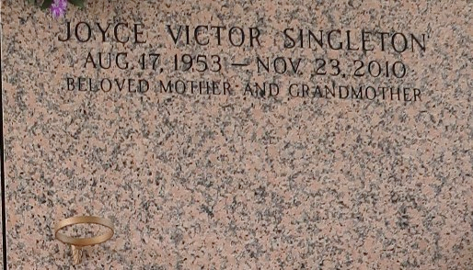

Joyce Marie Victor Singleton on Tuesday, November 23, 2010 at Ochsner Hospital, Jefferson LA. Daughter of the late Paul and Stella Mae Victor.
Loving Mother of Milton (Kojuvona) Singleton, Jr. of LaPlace, LA and Jamall Singleton of Reserve, LA. Sister of Terry (Elaine) Victor and the late Paul Victor. Grandmother of Barbara Singleton of Baton Rouge, LA, Taylor and Tyler Singleton of LaPlace, LA. Aunt of Jamaila Victor of Reserve, LA, Terri (Hilton) Millet of Kenner, LA, Kendell Paul Victor and Anthony Victor both of Lutcher, LA. Also survived by 4 aunts, 3 uncles, cousins, other relatives and friends. Age 57 years. A native and resident of Reserve, LA.
Relatives and friends of the family, also priest and parishioners of Our Lady of Grace Catholic Church and all neighboring churches and employees of Place DuBourg, Dupre' Transportation, Metrolift Propane and St John Parish Utilities are invited to attend the Mass of Christian Burial at Our Lady of Grace Catholic Church, 772 Hwy 44, Reserve, LA on Monday, November 29, 2010 at 11:00 AM. Fr. Joseph Rodney, Celebrant. Interment St John Memorial Garden Cemetery, LaPlace, LA. Visitation at the above-named church from 9:00 AM until Mass time. SERVICED BY ROBOTTOM

The Times-Picayune, New Orleans, Louisiana
November 28, 2010

