William Singleton
September 10, 1950 – September 5, 2008
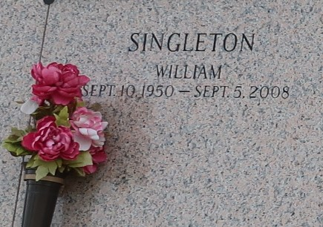

William "Big Will" Singleton departed this earthly life on Friday, September 5, 2008 at East Jefferson General Hospital of Metairie, LA. Son of Odeal Singleton of Reserve, LA and the late Willie Singleton. Beloved husband of Myrtis B. Singleton of Reserve, La. Loving father and father-in-law of Chanda (Kirk) Noel, Christina Singleton, Candace Singleton and Danaisha Martin. Brother /brother-in-law of Burnet (Millie) Singleton, David Singleton, Theresa (Roosevelt) Chambers of Reserve, LA, James (Debra) Singleton of Lacey, WA and Shirley Singleton of LaPlace, LA. Also survived by 6 grandchildren, a host of nieces, nephews, other relatives and friends. A native and resident of Reserve, LA. Age 57 years.
Relatives and friends of the family; also pastors, officers and members of Mt. Zion Baptist Church of Garyville, LA and all neighboring churches are invited to attend the Funeral Services on Friday, September 12, 2008 at 11:00 a.m. at Mt. Zion Baptist Church, 144 Little Hope St., Garyville, LA. Rev. Arthur Joseph, officiating. interment in St. John Memorial Garden, LaPlace, LA. Visitation will be at the Church from 9:00 a.m. until service time. Bardell's Mortuary of Mt. Airy, LA in charge. Information: (985) 535-6837.

The Times-Picayune, New Orleans, Louisiana
September 12, 2008

