Jean Aster (Glenn) Slayton
February 11, 1934 – May 9, 2016
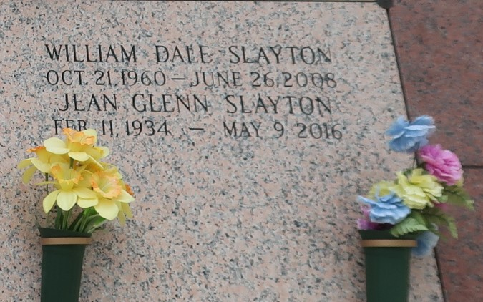

Jean Aster Slayton passed away on Monday, May 9, 2016 in Hammond, LA. She was a native of Decatur, Alabama and a resident of LaPlace, Louisiana. Beloved mother of Pam de St. Germain, Jeffery Slayton and his wife Amanda and the late Dale Slayton. Grandmother of Amber de St. Germain, Megan de St. Germain, John de St. Germain, Danielle de St. Germain, Joshua Slayton, Amy Slayton, Phillip Bourgeois, Loni Bourgeois, Drew Slayton, Trevor Slayton and Samantha Peters. Great Grandmother of Madison Richard, Roselynn de St. Germain, Kasey Bourgeois and Kallie Bourgeois. Daughter of the late Jasper Glenn and Stella Ingram Glenn. She is also survived by one brother Elmer Glenn.
Relatives and friends are invited to attend the Funeral Service at Millet-Guidry Funeral Home, 2806 W. Airline Hwy, LaPlace on Friday, May 13, 2016 at 12:30 p.m. Visitation will be held from 10:00 a.m. to time of services. Inurnment will be held in St. John Memorial Garden Cemetery in LaPlace at a later date. To view or sign the online guest book please visit www.milletguidry.com.
The New Orleans Advocate, Louisiana
May 11 to May 13, 2016

