Bonnie Mae (Chiles) Smith
August 25, 1919 – April 8, 2001
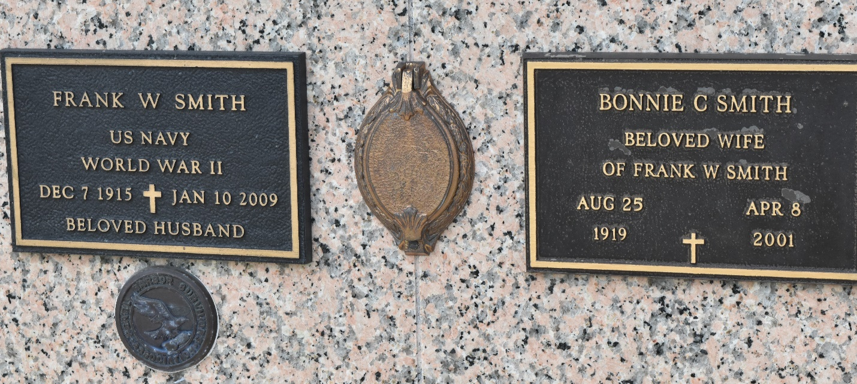

SMITH, BONNIE C., age 81; beloved wife of Frank W. Smith, both formerly of St. Louis; died April 8, 2001, in Kenner, LA; daughter of the late Minnie Ann Hicks and Lyman Earl Chiles; sister of Joan Gist, Dorothy Spehr, the late Earl Fremon and Gene Chiles; sister-in-law, aunt and godmother.
Private interment in St. John Memorial Gardens, in LaPlace, LA. Kenner Funeral Home oa L.A. Muhleisen & Son, in charge of arrangements.
St. Louis Post-Dispatch, Missouri
April 10, 2001
Page 33

