Charles Leon Smith
April 21, 1931 - November 11, 2015
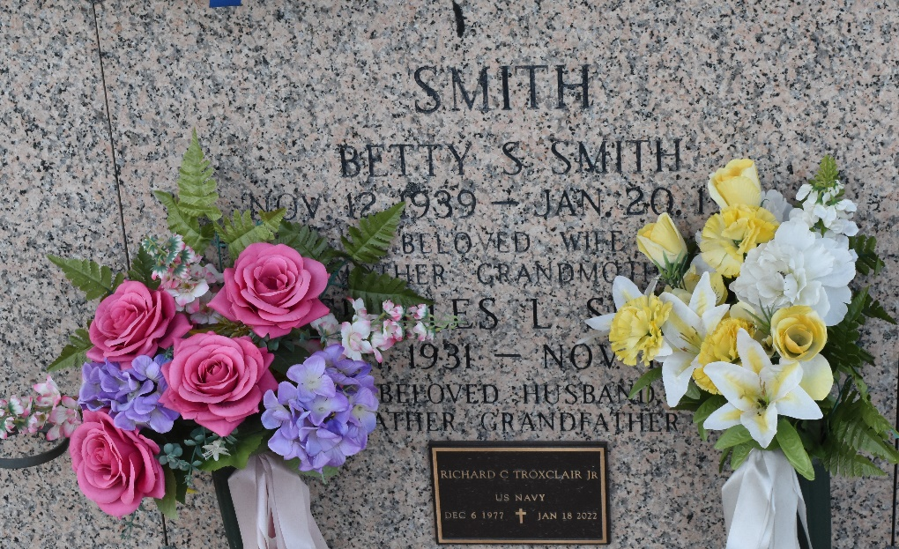

Charles Leon Smith, to the sadness of his family, left this earth on November 11, 2015. Born in Hentin, Oklahoma on April 21, 1931to Stillwell and Minnie Smith. Lived in the New Orleans area for the last 55 years. Missed by sister Sylvia Carson. Preceded in death by his brothers Ira, L. Carl, Stoney, Leroy William; and sisters Bonnie and Tinnie.
Cherished by his wife of the last 20 years, Betty “Toddy” Smith. Preceded in death by his first wife, Betty S. Smith. Loved by son David (Mary); daughter Susan Tubre (Bob); son James “Randy” Smith (Valerie); son Mark (DeeDee); daughter Jody Parmer (Paul); daughter Lisa Juneau; son Terry Juneau (Marilee) and son Rick Juneau. Also survived by numerous nieces, nephews, grandchildren and great-grandchildren.
Charles was a true gentleman and friend. His humble demeanor is expressed in his request for no memorial service.
Published by Legacy Remembers on Nov. 13, 2015

