Frank Wilson Smith
December 7, 1915 – January 10, 2009
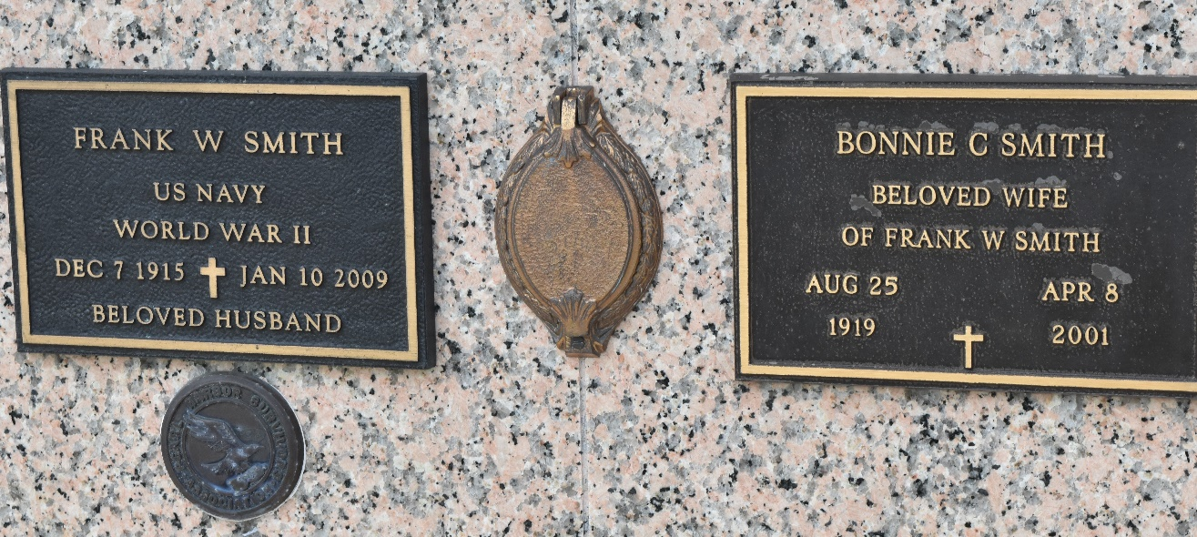

Frank Wilson Smith passed away on Saturday, January 10, 2009 at the age of 93 in Reserve, LA.
Beloved husband of the late Bonnie Chiles Smith, son of the late Sidney B. Smith and Mary R. Smith and brother of the late Sidney B. Smith, Jr. all from St. Louis, MO. Brother-in-law of Bill and Joan Gist of Kenner, LA and the late Alice Smith of St. Louis, MO, Larry and Dorothy Spehr of Ocean Springs, MS and Earl, Fremon and Eugene Chiles of St. Louis, MO. Godfather of Donna Nold of Metairie, LA. Uncle of Mary Smith Scheffler of Lander, TX, James Smith of Florida, Gary and Colleen Gist of Folsom, LA, Donna and Steve Nold of Metairie, LA, Karen Gist of St. Louis, MO, Sherry Chiles Forman of St. Peters, MO, Randy and Sue Chiles of Catawissa, MO and Sandy and Charles Crane of Wichita, KS. He is also survived by great-nieces and nephews.
Mr. Smith retired in 1980 from the U. S. Dept. of Defense in St. Louis, MO where he worked for 29 years making maps and charts in the photography department. He was a WW II US Navy Veteran and President of the Pearl Harbor Survivor Association/Ed Jones Chapter, a member of American Legion Post 350 and the Military order of the Purple Heart Post 1955 both in Metairie, LA. Interment will be in St. John Memorial Gardens, LaPlace, LA.
Arrangements by L. A. Muhleisen and Son Funeral Home.
Times Picayune, New Orleans, Louisiana
January 18, 2009

