Marshall Lee Smith Jr.
May 29, 1939 – May 1, 2014
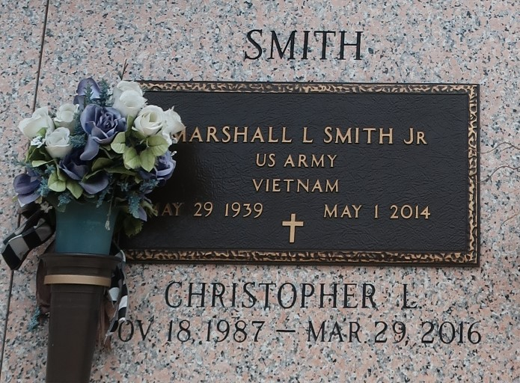

MARSHALL LEE SMITH, JR. on Thursday, May 1, 2014 at his home in LaPlace, LA. Son of the late Willie Mae Levy and Marshall Smith, Sr. Husband of Evelyn Acker Smith. Father of Marshall L. Smith, III, Christopher L. Smith, Leroy J. Sanders and Tyrone Sanders. Brother of Bobby S. Marshall, George R. Smith, the late Lyddie S. Price, Ross A. Smith and Charles Smith. Grandfather of Leroy J. Sanders, III, Tahj Sanders and Ro Maiero J. Sanders. Also survived by 7 sisters in law, 7 brothers in law and a host of nieces, nephews, cousins, other relatives and friends. Age 74 years. A native of Brookhaven, MS and a resident of LaPlace, LA.

Relatives and friends of the family, also pastors, officers and members of Beech Grove Baptist Church and all neighboring churches, employees of Federal Aviation Administration and Lakeside Hospice are invited to attend the Funeral Service at Beech Grove Baptist Church, 117 Beech Grove Drive, Reserve, LA on Saturday, May 10, 2014 at 10:30 AM Rev. Wesley Anderson, Sr., Pastor, Rev. Jeff Patterson, Officiating Interment St. John Memorial Garden Cemetery, LaPlace, LA Visitation at the above named church from 9:00 AM until Service Time. SERVICED BY ROBOTTOM
Times Picayune, New Orleans, Louisiana
May 7-9, 2014

